

**Electrical Safety Form**

|  |
| --- |
| Car E217 |
| [RCJ10@zips.uakron.edu](mailto:RCJ10@zips.uakron.edu) |

Table of Contents

Table of Contents iii

I List of Figures ix

II List of Tables xiii

III List of Abbreviations xiv

1 System Overview 2

2 Electrical Systems 2

2.1 Shutdown Circuit 2

2.1.1 Description/concept 2

2.1.2 Wiring / additional circuitry 5

2.1.3 Position in car 7

2.2 IMD 9

2.2.1 Description (type, operation parameters) 9

2.2.2 Wiring/cables/connectors/ 10

2.2.3 Position in car 11

2.3 Inertia Switch 11

2.3.1 Description (type, operation parameters) 11

2.3.2 Crash Sensor 12

2.3.3 Wiring/cables/connectors/ 12

2.3.4 Position in car 13

2.4 Brake Plausibility Device 13

2.4.1 Description/additional circuitry 13

2.4.2 Wiring 14

2.4.3 Position in car/mechanical fastening/mechanical connection 14

2.5 Reset / Latching for IMD and BMS 15

2.5.1 Description/circuitry 15

2.5.2 Wiring/cables/connectors 16

2.5.3 Position in car 16

2.6 Shutdown System Interlocks 17

2.6.1 Description/circuitry 17

2.6.2 Wiring/cables/connectors 17

2.6.3 Position in car 18

2.7 Tractive system active light (TSAL) 18

2.7.1 Description/circuitry 18

2.7.2 Wiring/cables/connectors 19

2.7.3 Position in car 20

2.8 Measurement points 21

2.8.1 Description 21

2.8.2 Wiring, connectors, cables 21

2.8.3 Position in car 23

2.9 Pre-Charge circuitry 23

2.9.1 Description 23

2.9.2 Wiring, cables, current calculations, connectors 23

DAR72410P 26

2.9.3 Position in car 26

2.10 Discharge circuitry 28

2.10.1 Description 28

2.10.2 Wiring, cables, current calculations, connectors 29

UAL10-2KF8 - Wirewound 31

DBR72410P 31

2.10.3 Position in car 32

2.11 HV Disconnect (HVD) 33

2.11.1 Description 33

2.11.2 Wiring, cables, current calculations, connectors 33

2.11.3 Position in car 35

2.12 Ready-To-Drive-Sound (RTDS) 35

2.12.1 Description 35

2.12.2 Wiring, cables, current calculations, connectors 36

2.12.3 Position in car 36

3 Accumulator 37

3.1 Accumulator pack 1 37

3.1.1 Overview/description/parameters 37

3.1.2 Cell description 41

3.1.3 Cell configuration 42

3.1.4 Cell temperature monitoring 42

3.1.5 Battery management system 42

3.1.6 Accumulator indicator 46

3.1.7 Wiring, cables, current calculations, connectors 47

3.1.8 Accumulator insulation relays 49

3.1.9 Fusing 49

3.1.10 Charging 51

3.1.11 Mechanical Configuration/materials 53

3.1.12 Position in car 54

3.2 Accumulator pack 2 55

4 Energy meter mounting 56

4.1 Description 56

4.2 Wiring, cables, current calculations, connectors 56

4.3 Position in car 56

5 Motor controller 57

5.1 Motor controller 1 57

5.1.1 Description, type, operation parameters 57

5.1.2 Wiring, cables, current calculations, connectors 58

5.1.3 Position in car 58

5.2 Motor controller 2 59

6 Motors 60

6.1 Motor 1 60

6.1.1 Description, type, operating parameters 60

6.1.2 Wiring, cables, current calculations, connectors 61

6.1.3 Position in car 62

6.2 Motor 2 62

7 Torque encoder 63

7.1 Description/additional circuitry 63

7.2 Torque Encoder Plausibility Check 63

7.3 Wiring 64

7.4 Position in car/mechanical fastening/mechanical connection 65

8 Additional LV-parts interfering with the tractive system 66

8.1 LV part 1 – GLVS BMS 66

8.1.1 Description 66

8.1.2 Wiring, cables, 67

8.1.3 Position in car 68

8.2 LV part 2 Traction Control System 68

9 Overall Grounding Concept 69

9.1 Description of the Grounding Concept 69

9.2 Grounding Measurements 69

10 Firewall(s) 70

10.1 Firewall 1 70

10.1.1 Description/materials 70

10.1.2 Position in car 71

10.2 Firewall 2 71

11 Appendix 72

11.1 System Overview 72

11.1.1 18 AWG PVC Insulated Hookup Wire 72

11.1.2 24 AWG PVC Insulated Hookup Wire 73

11.1.3 TSMS/HV Sense Wire 74

11.2 Electrical System Datasheets 75

11.2.1 Shutdown Circuit 75

11.2.1.1 E-Stop Switches 75

11.2.1.2 Tractive System Master Switch 76

11.2.2 Bender IR155-3203 IMD 77

11.2.3 Crash Sensor 78

11.2.3.1 Sensata resettable inertial switch 78

11.2.4 Brake Plausibility 79

11.2.4.1 Honeywell Brake Pressure Sensor 79

11.2.5 IMD/BMS Reset 80

11.2.6 Shutdown System Interlocks 81

11.2.7 Tractive System Active Light 82

11.2.7.1 100 Lumen LED 82

11.2.8 Tractive System Measurement Points 82

11.2.8.1 TSMP Box 82

11.2.8.2 TSMP Jacks 84

11.2.8.3 TSMP Resistors 84

11.2.9 Precharge Circuitry 85

11.2.9.1 150 Ω Precharge Resistors 85

11.2.9.2 Precharge High Voltage Relays 85

11.2.10 Discharge Circuitry 86

11.2.10.1 Discharge Resistors 86

11.2.10.2 Discharge Relays 87

11.2.11 High Voltage Disconnect 88

11.2.12 Ready To Drive Sound 89

11.2.12.1 Ready to Drive Horn 89

11.3 Accumulator 91

11.3.1.1 High Voltage Battery 91

11.3.1.2 Maintenance Plugs 92

11.3.1.3 Accumulator Isolation Relay 93

11.3.1.4 High Voltage Fuse 94

11.3.1.5 HV Fuse Holder 95

11.3.1.6 BMS Sense Fuse 96

11.3.1.7 Charger 97

11.4 Energy Meter 98

11.5 Motor Controller 99

11.5.1 Rinehart Motion Systems PM100DX 99

11.5.2 EXRAD Shielded Cable 100

11.6 Motor(s) 101

11.6.1 EMRAX 228 101

11.7 Torque Encoder 102

11.7.1 Active Sensors Linear Potentiometer 102

11.8 LV Parts 103

11.8.1 Low Voltage BMS 103

11.8.1.1 Low Voltage Battery 103

11.9 Grounding Concept 104

11.10 Firewall 105

# List of Figures

Figure 1. High Level Electrical System Block Diagram 2

Figure 2. High Level Tractive System Battery Layout 4

Figure 3. Tractive System Master Switch and Key 2

Figure 4 TSMS and GLVMS in the OFF position 3

Figure 5 TSMS and GLVMS in the ON position 3

Figure 6 Safety Circuit Layout 5

Figure 7 AIR Controller 6

Figure 8 Pre-Charge/Discharge Circuit 6

Figure 9 E-Stop Placement 7

Figure 10 E-Stop Placement 8

Figure 11 Inertia Switch Placement 8

Figure 12 Crash Sensor Placement 9

Figure 13 BMS & IMD Indicator Lights 9

Figure 14 IMD Wiring Diagram 10

Figure 15 IMD Placement in Accumulator 11

Figure 16 Inertia Switch Placement in Car 13

Figure 17. Brake Plausibility Schematic 14

Figure 18 Brake Plausibility/ECU Location 15

Figure 19 IMD Schematic 16

Figure 20 IMD Placement in Accumulator (Global View) 16

Figure 21 Control Circuitry Placement 17

Figure 22 Interlock Schematic 18

Figure 23 HVD placement 18

Figure 24 TSAL Control Schematic 19

Figure 25 TSAL Schematic 20

Figure 26 TSAL Posiition in Car 20

Figure 27 Tractive System Measurement Points 21

Figure 28 Tractive System Measurement Resistors 22

Figure 29 Tractive System Measurement Point in Car 23

Figure 30 Pre-Charge Schematic 24

Figure 31 Pre-Charge Schematic 2 24

Figure 32 Pre-Charge Graph 25

Figure 33 Pre-Charge Relay and Resistor Positions 27

Figure 34 Pre-Charge Control Position 28

Figure 35 Discharge Voltage Graph 29

Figure 36 Discharge Current Graph 29

Figure 37 Discharge Circuit 30

Figure 38 Discharge Circuit Position in Tractive Electrical System 30

Figure 39 Discharge Relay & Resistor Position 32

Figure 40 Position of Control Circuitry in Car 33

Figure 41 HVD Connector 34

Figure 42 HVD Position in Car 35

Figure 43 Horn Control Circuitry 36

Figure 44 Horn Position in Car 36

Figure 45 Accumuluator Battery Layout 38

Figure 46 Accumulator Battery Layout (High Level) 39

Figure 47 Accumulator Box Right (Box1-70s2p) 39

Figure 48 Accumulator Box Left (Box2-70s2p) 40

Figure 49 Battery Pack Modules (10s2p) x7 per container ~42v 41

Figure 50 IMD & BMS Status Light 43

Figure 51 Battery Management Slave Schematic 44

Figure 52 Battery Management Master Schematic 45

Figure 53 Battery Management Isolation Board (Master/Slave Isolation) 46

Figure 54 Accumulator Connector (Low Voltage) 48

Figure 55 Accumulator Fusing 50

Figure 56. Full Accumulator Pod 54

Figure 57. Accumulator Battery Module (<6MJ) 54

Figure 58. Accumulator Position in Car 54

Figure 59 Motor Controller Wiring Diagram 58

Figure 60 Motor Controler Position in Car 59

Figure 61 Motor Torque/Speed & Power/Speed Data 61

Figure 62 Motor Position in Car (Rear & Isometric View) 62

Figure 63 Throttle Sensor Fault Conditions 64

Figure 64 Throttle Pedal and Sensor Position in Car 65

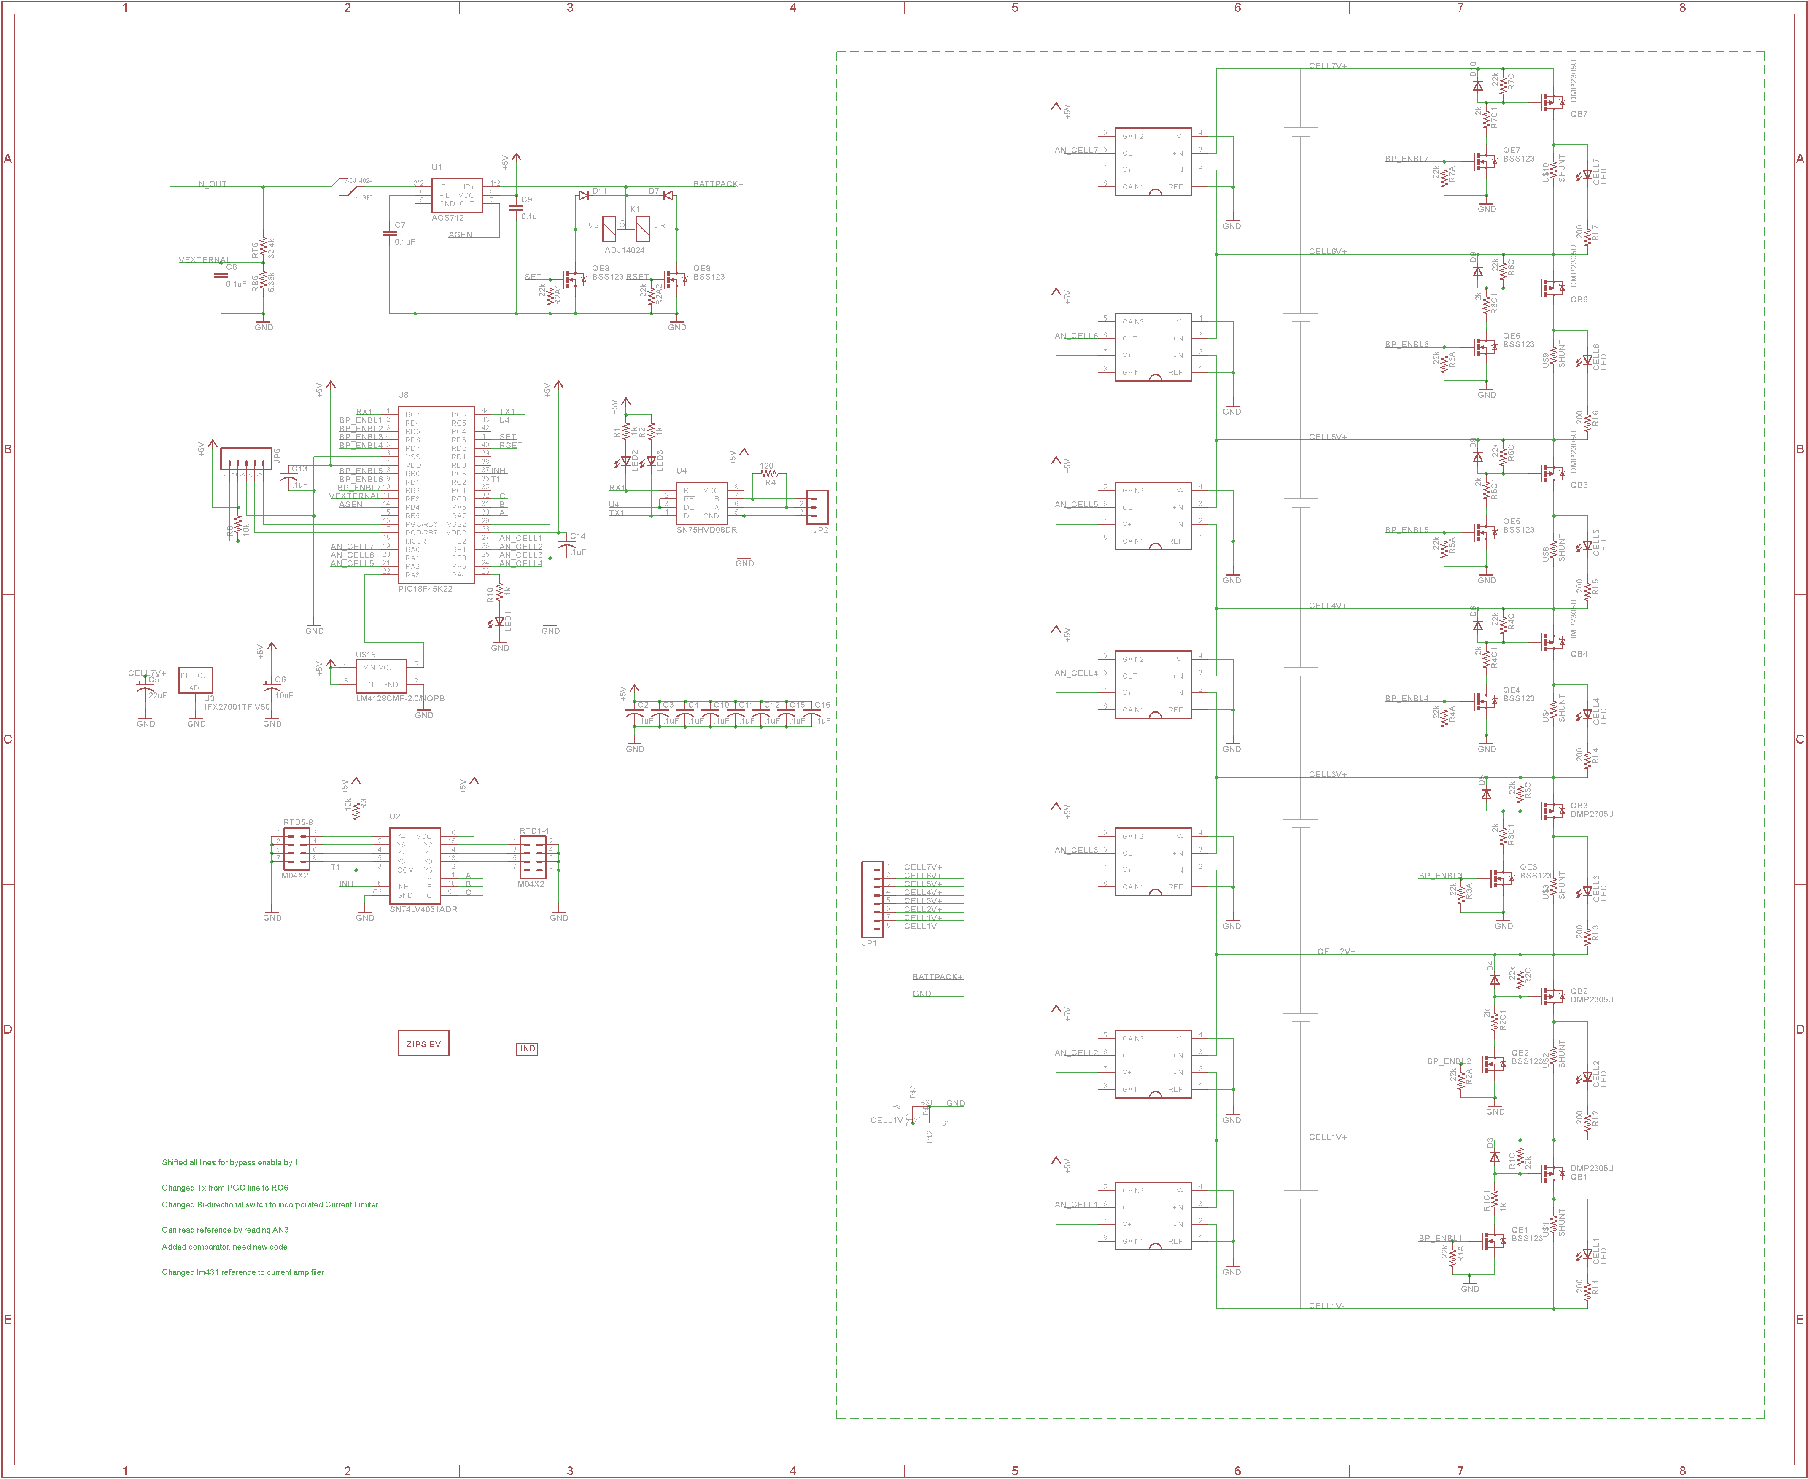Figure 65. GLVS Wiring and BMS circuit 67

Figure 66. GLVS battery pack location in car 68

# List of Tables

Table 1.1 General parameters 3

Table 2.1 List of switches in the shutdown circuit 4

Table 2.2 Wiring – Shutdown circuit 7

Table 2.3 Parameters of the IMD 10

Table 2.4 Parameters of the Inertia Switch 12

Table 2.5 Torque encoder data 14

Table 2.6 Parameters of the TSAL 19

Table 2.7 General data of the pre-charge resistor 25

Table 0.1 General data of the pre-charge relay 26

Table 0.1 General data of the discharge circuit 31

Table 3.1 Main accumulator parameters 37

Table 3.2 Main cell specification 42

Table 3.3 Accumulator Indicator hookup wire specs 47

Table 3.4 Basic AIR data 49

Table 3.5 Basic fuse data 49

Table 3.6 Fuse Protection Table 51

Table 3.7 General charger data 51

Table 5.1 General motor controller data 57

Table 5.2 Wire data of Champlain Exrad Shielded Cable 58

Table 6.1 General motor data 60

Table 7.1 Torque encoder data 63

# List of Abbreviations

* HV: High Voltage
* GLVS: Grounded Low Voltage System
* BMS: Battery Management System
* BMM: Battery Management System Master
* BMSS: Battery Management System Slave (S)
* SAS: Sensor Acquision System
* MCS: Motor Controller System
* SS: Safety System
* DDS: Dasboard Display System

# System Overview

The Zips Electric Racing 2016 car is a rear wheel drive electric race car sporting a single 79kW motor and a 296 cell (72 series 3 parallel) lithium polymer battery pack. The car is run and controlled by two separate electrical systems, a high voltage (HV) tractive system and grounded low voltage (GLV) system. The tractive system consists of motors, motor controllers, accumulators, AIR’s main fusing, and battery management. The GLV system includes control systems, communications, sensors and a portion of the battery management system (BMS)

Figure 1. High Level Electrical System Block Diagram

|  |  |
| --- | --- |
| Maximum Tractive-system voltage: | 302.4VDC |
| Nominal Tractive-system voltage: | 295.2VDC |
| Control-system voltage: | 24VDC |
| Accumulator configuration: | 72s3p |
| Total Accumulator capacity: | 21.15Ah 6.24 kW-hours; 22.47MJ |
| Motor type: | Permanent Magnet Brushless AC |
| Number of motors: | Total 1 with mechanical differential |
| Maximum combined motor power in kW | 79kW |

Table 1.1 General parameters

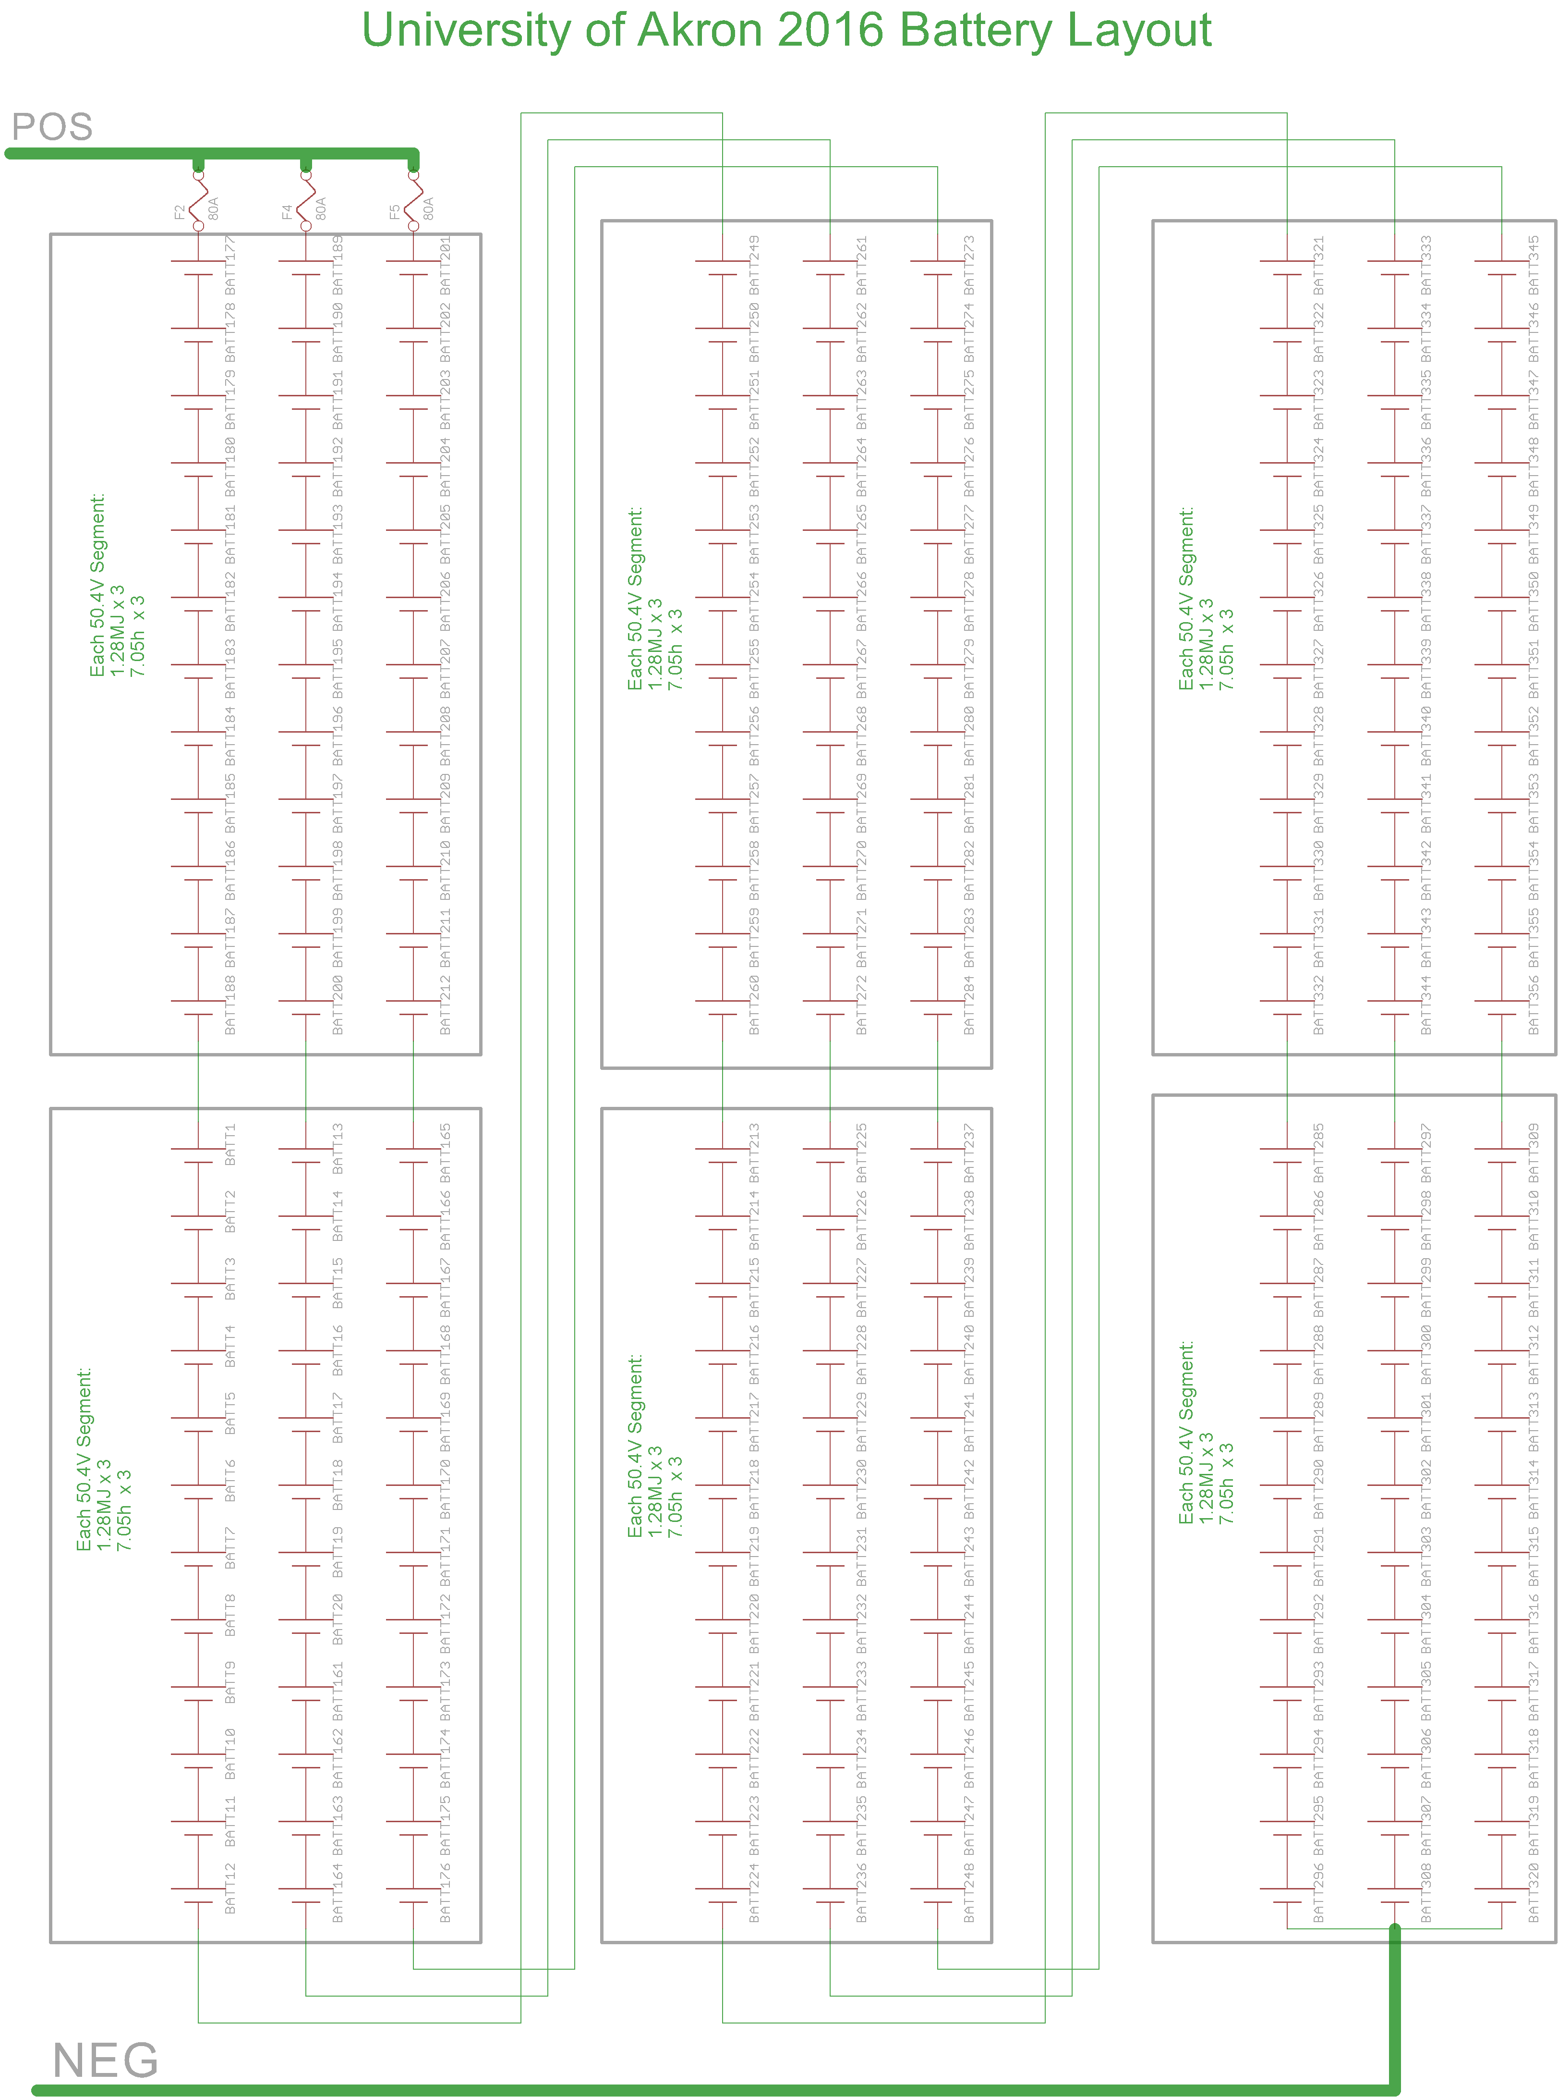

Figure 2. High Level Tractive System Battery Layout

# Electrical Systems

## Shutdown Circuit

### Description/concept

The shutdown circuit consists of a series loop with multiple switches that make or break the control line (powered by the GLVS custom battery pack) to the normally open Accumulator Isolation Relays (AIRs). If any individual switch breaks the loop, the AIRs open and disconnect the accumulator, removing high voltage from the tractive system. System failures that automatically shut down the car include brake over travel (caused by loss of brake pressure), BMS fault (battery over temp. etc.), IMD (loss of isolation), and brake plausibility.

The ECU relay controls the car precharge (EX: the car in a non-ready-to-drive state) until the start button is hit and brake pedal is depressed. The safety circuit and ECU relay prevent the car from entering ready to drive mode if any external faults are present. The ECU relay is used to add hardware and software lockouts. The safety system faults are only cleared with a car power down (AMS,IMD, BSPD), but continuously monitored when powered up again. The shutdown system also examines where the fault occurred to alert the problem.

The car may also be shut down or prevented from starting by E-Stop Switches and the Tractive System Master Switch (TSMS), and High Voltage Disconnect (HVD). The TSMS shown in below is operated by a red key which the safety officer controls. This ensures that the car cannot be started without the safety officer present.

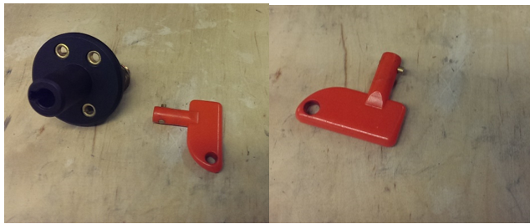

Figure 3. Tractive System Master Switch and Key

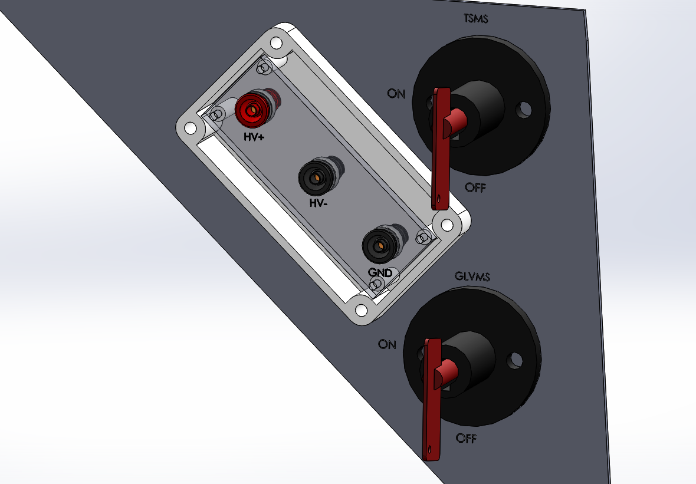

Figure 4 TSMS and GLVMS in the OFF position

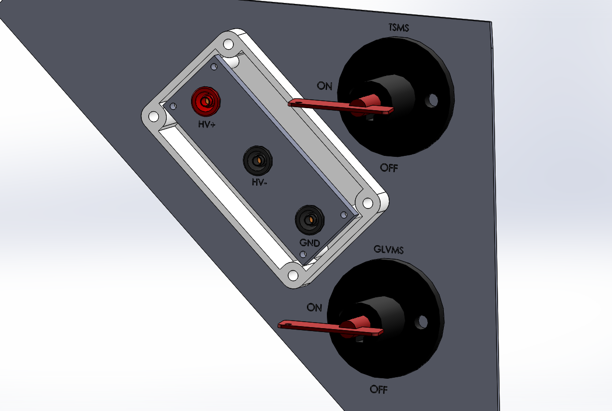

Figure 5 TSMS and GLVMS in the ON position

|  |  |
| --- | --- |
| Part | Function |
| Main Switch (for control and tractive-system; CSMS, TSMS) | Normally open |
| Brake over travel switch (BOTS) | Normally closed |
| Shutdown buttons (SDB) | Normally closed |
| Insulation Monitoring Device (IMD) | Normally closed |
| Battery Management System (BMS) | Normally closed |
| Inertia Switch | Normally closed |
| Interlocks | Closed when connectors are closed |
| Brake System Plausibility Device | Normally Closed |
| Software System (ECU) | Normally Closed |

Table 2.1 List of switches in the shutdown circuit

### Wiring / additional circuitry

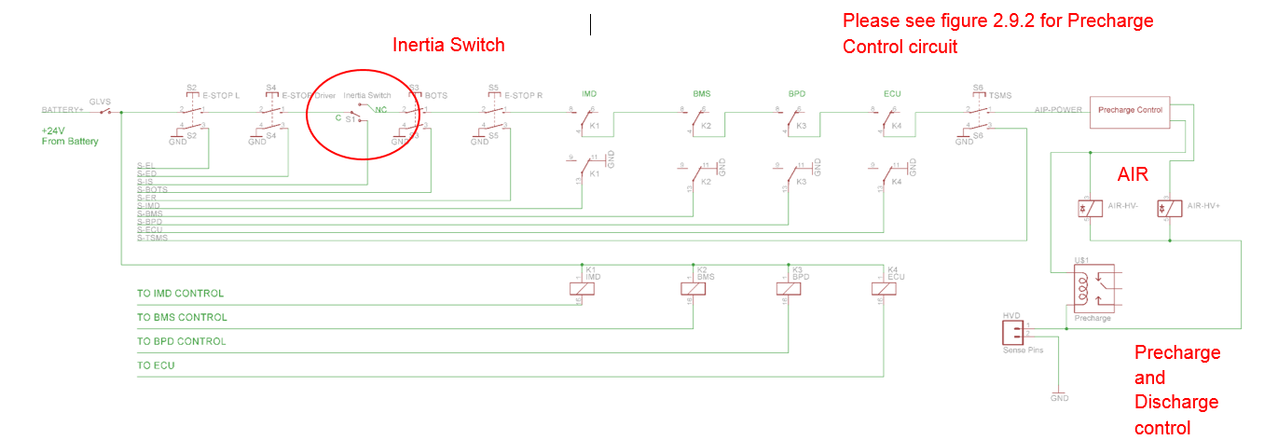

Figure 6 Safety Circuit Layout

Main and Pre+ are outputs of the pre charge control circuitry.

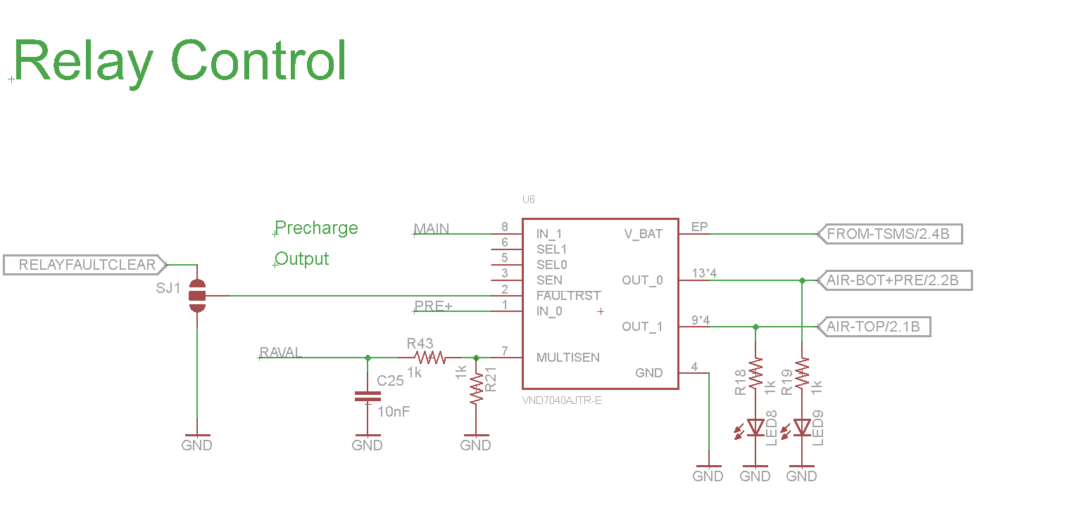

Figure 7 AIR Controller

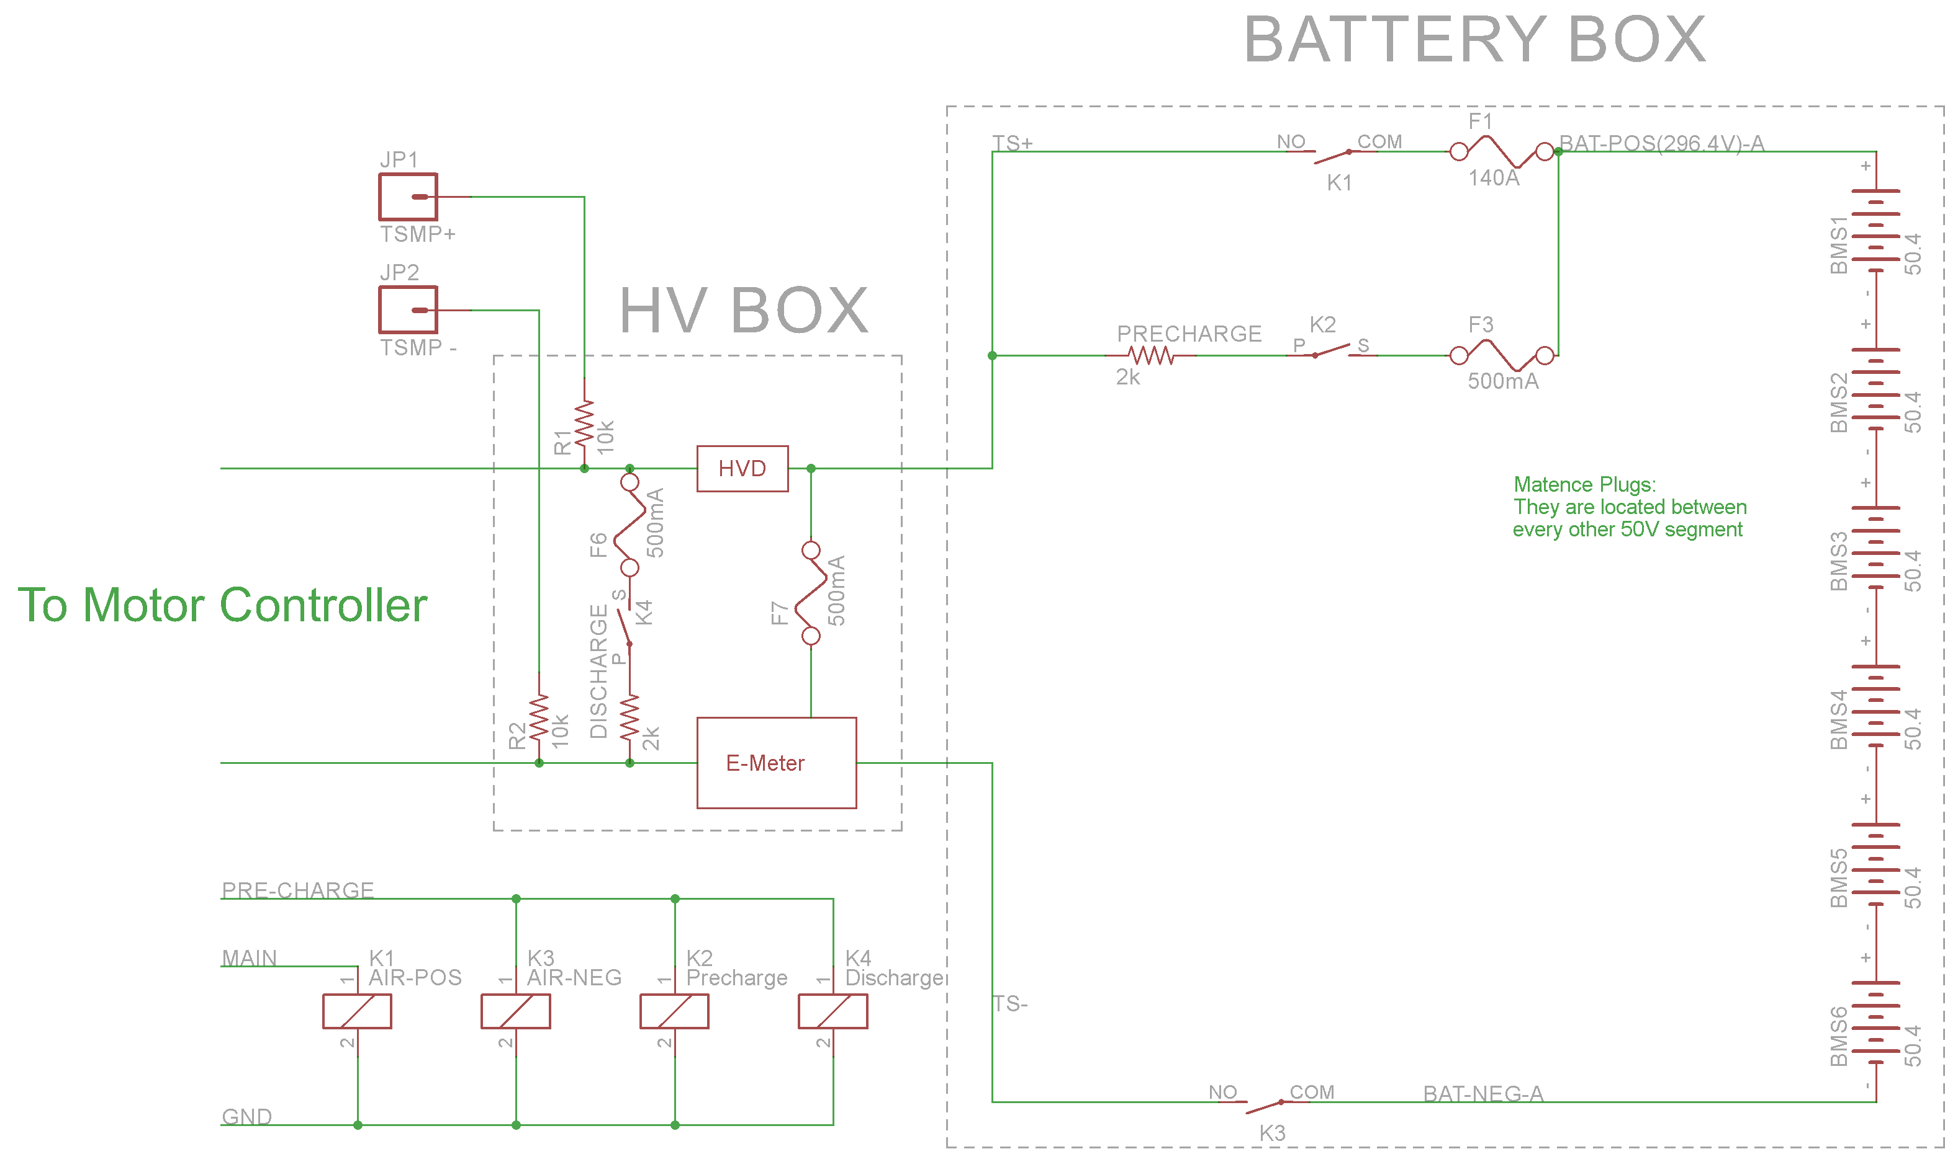

Discharge

Precharge

Figure 8 Pre-Charge/Discharge Circuit

|  |  |
| --- | --- |
| Total Number of AIRs: | 2 |
| Current per AIR: | 0.5A |
| Additional parts consumption within the shutdown circuit: | 1A |
| Total current: | 2A |
| Cross sectional area of the wiring used: | 0.205 mm² |

Table 2.2 Wiring – Shutdown circuit

### Position in car

Disconnect, driver e-stop, and left e-stop:

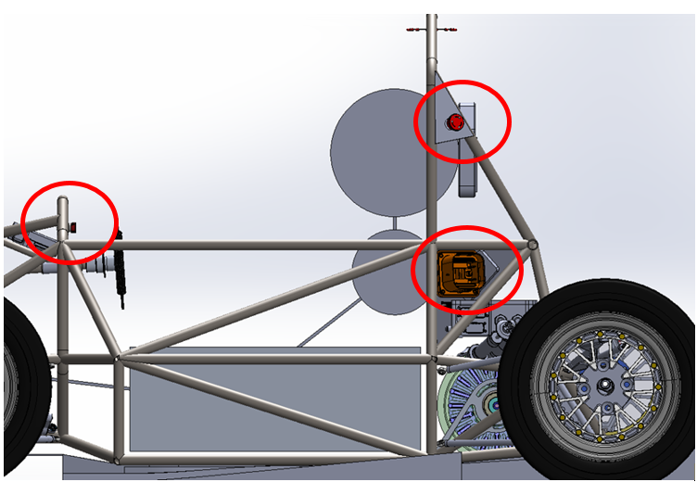

Figure 9 E-Stop Placement

Driver e-stop, right e-stop and left e-stop:

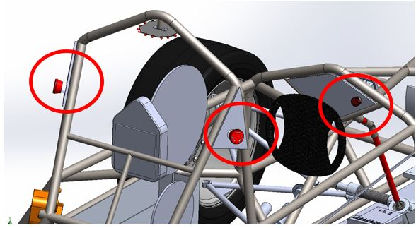

Figure 10 E-Stop Placement

BOTS:

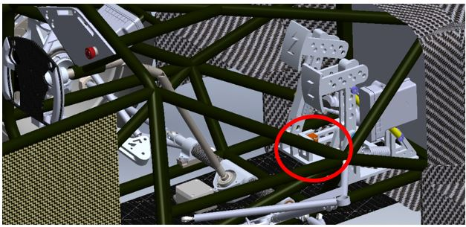

Figure 11 Inertia Switch Placement

Inertia Switch:

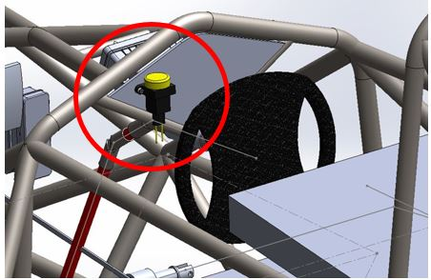

Figure 12 Crash Sensor Placement

## IMD

### Description (type, operation parameters)

Bender IR155-3203 IMD, Automatic Device Self-test and Continuous measurement of insulation resistance. The indicator is wired to the front dash. The LED is lit by software cue from the safety system (SS) to the Dashboard Display System DDS controller warning the driver. The system is not able to be reset unless there is a GLVMS power cycle.

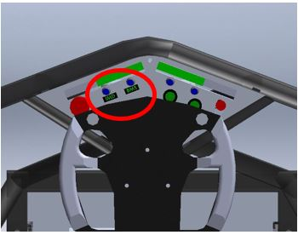

Figure 13 BMS & IMD Indicator Lights

|  |  |
| --- | --- |
| Supply voltage range: | 10..36VDC |
| Supply voltage | 24VDC |
| Environmental temperature range: | -40..105°C |
| Selftest interval: | Always at startup, then every 20 minutes |
| High voltage range: | DC 0..1000V |
| Set response value: | 300kΩ (500Ω/Volt) |
| Max. operation current: | 500mA |
| Approximate time to shut down at 50% of the response value: | 27s |

Table 2.3 Parameters of the IMD

### Wiring/cables/connectors/

The IMD requires 11.1.224 AWG PVC Insulated Hookup Wire with a 300v and 105C rating.

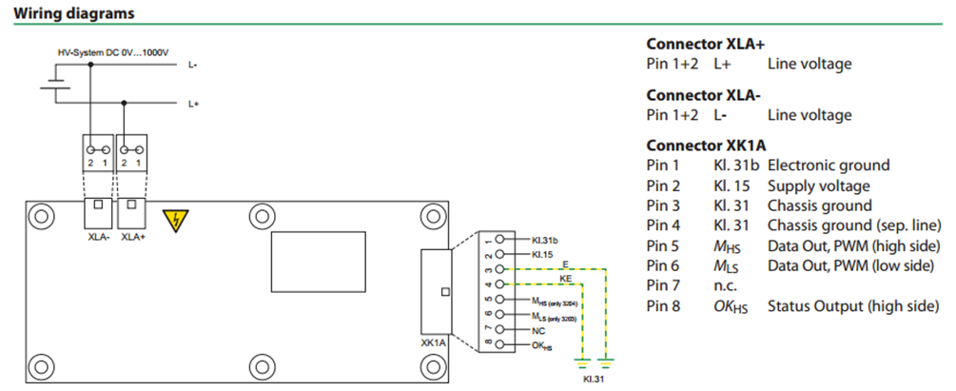

Figure 14 IMD Wiring Diagram

### Position in car

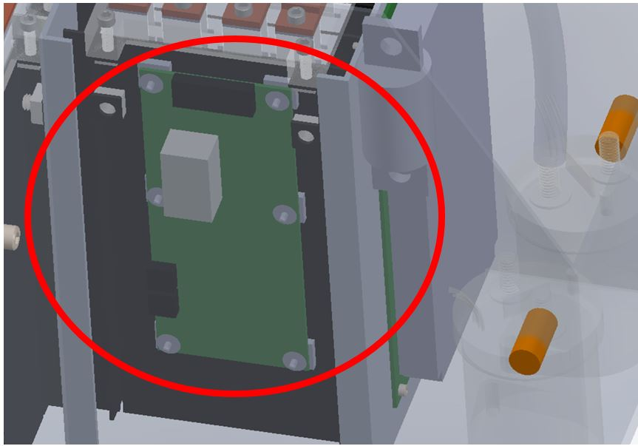

Figure 15 IMD Placement in Accumulator

## Inertia Switch

### Description (type, operation parameters)

### Crash Sensor

Sensata resettable inertial switch will be normally closed and will open to shut down the tractive system in the event of a crash. This is hooked up in series with the other safety switches that control the AIR’s so if it went off the tractive system would become unpowered. The driver will have the ability to depress the Sensata crash sensor to reset it. The crash sensor is removable from the dashboard with two screws and an electrical connector to allow for testing the device at competition.

|  |  |
| --- | --- |
| Inertia Switch type: | Sensata resettable inertial switch XYZ |
| Supply voltage range: | 10..36VDC |
| Supply voltage: | 24VDC |
| Environmental temperature range: | -40..105°C |
| Max. operation current: | 10A |
| Trigger characteristics: | 6g for 50ms / 11g for 15ms |

Table 2.4 Parameters of the Inertia Switch

### Wiring/cables/connectors/

The crash sensor will be rigidly mounted to the frame of the car near the bottom to ensure that it receives the full force of any vibration or impact using a mating connector and 18 AWG PVC Insulated Hookup Wire 105C, 300v wire will be used for the electrical connections.

### Position in car

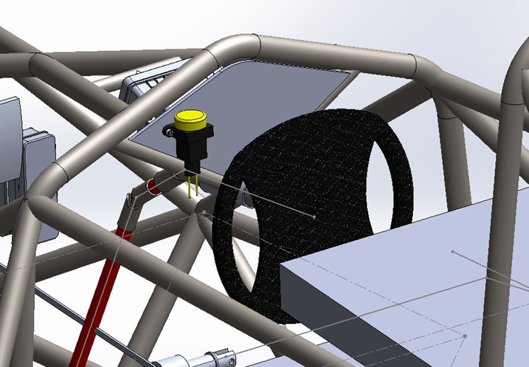

Figure 16 Inertia Switch Placement in Car

## Brake Plausibility Device

### Description/additional circuitry

The purpose of the brake plausibility system is to ensure that the brake pedal does not pass a certain threshold if the motors are being driven. It will work by using Honeywell Brake Pressure Sensors to measure braking and a current sensor on the connection between the accumulator and motor controllers to measure the current. These measured values will be compared by op-amps to pre-calculated constant threshold values set by potentiometers. The current set point is at 16.6A. To reset this system, it requires a GLVMS power cycle.

|  |  |
| --- | --- |
| Brake sensor used: | PX2AF1XX500PAAAX (See 11.2.4.1) |
| Torque encoder (current sensor) used: | Current shunt |
| Supply voltages: | 5V |
| Maximum supply currents: | 20mA |
| Operating temperature: | -40..100 °C |
| Output used to control AIRs: | Open a relay |

Table 2.5 Torque encoder data

### Wiring

The brake plausibility system takes a 9V power input from the LV power system, along with 0-5Vdigital sensor input from the brake pedal sensor and the current sensor on the motor supply. The only output is the on or off 24v relay power that goes to the shutdown circuit. The reset of this system is done by power cycling the GLVS or hitting the reset button.

### Position in car/mechanical fastening/mechanical connection

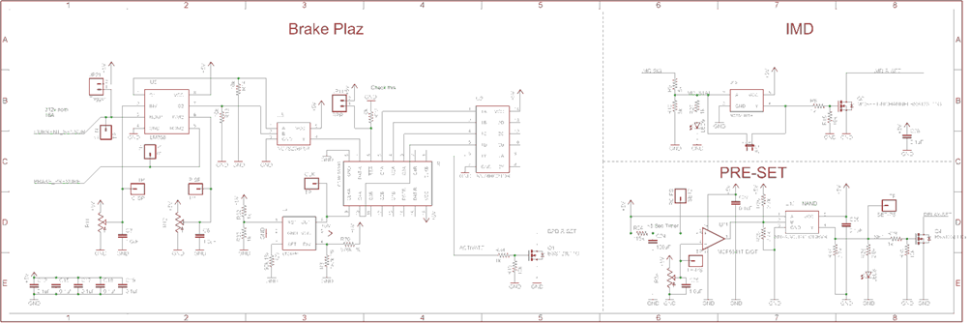

Figure 17. Brake Plausibility Schematic

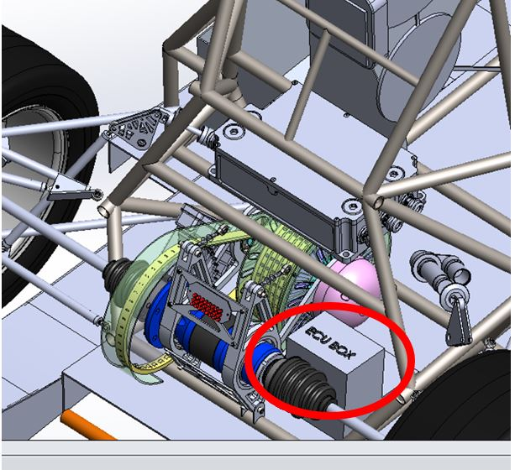

Figure 18 Brake Plausibility/ECU Location

## Reset / Latching for IMD and BMS

### Description/circuitry

If the IMD or BMS becomes tripped, the latching relays will open. A GLVS power cycle will reset these systems or pushing the reset button. The latching relays are set by the PRE-SET circuit. Below is the IMD hardware Safety System. The BMS is done in software but is only reset (turned on) during startup.



Figure 19 IMD Schematic

### Wiring/cables/connectors

The BMS and IMD relay is wired into the shutdown system in series with other safety systems. The Tractive system active light (TSAL) is wired with 24 AWG PVC Insulated Hookup Wire with a 300v and 105C rating. The BMS has a relay on the PCB that it can trip to open the shutdown circuit.

### Position in car

IMD:

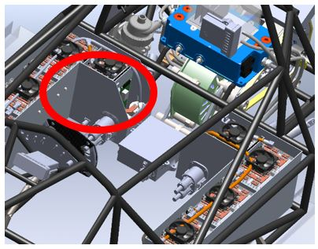

Figure 20 IMD Placement in Accumulator (Global View)

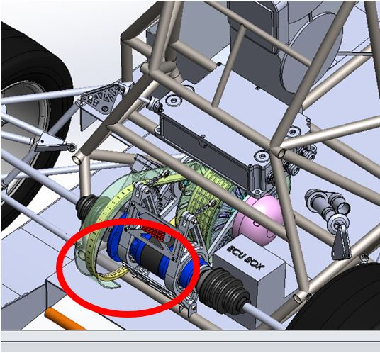

Figure 21 Control Circuitry Placement

## Shutdown System Interlocks

### Description/circuitry

The interlocks are achieved by using sense low voltage isolated pins in the connectors to detect open or closed connections. The AIR’s power travel through them. We have interlocks between the HVD. All other connectors will require tools to open.

### Wiring/cables/connectors

The HV Disconnect (HVD) requires 18 AWG PVC Insulated Hookup Wire with a 300v and 105C rating.

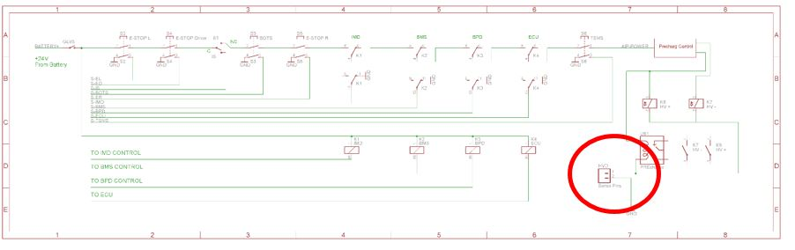

Figure 22 Interlock Schematic

### Position in car

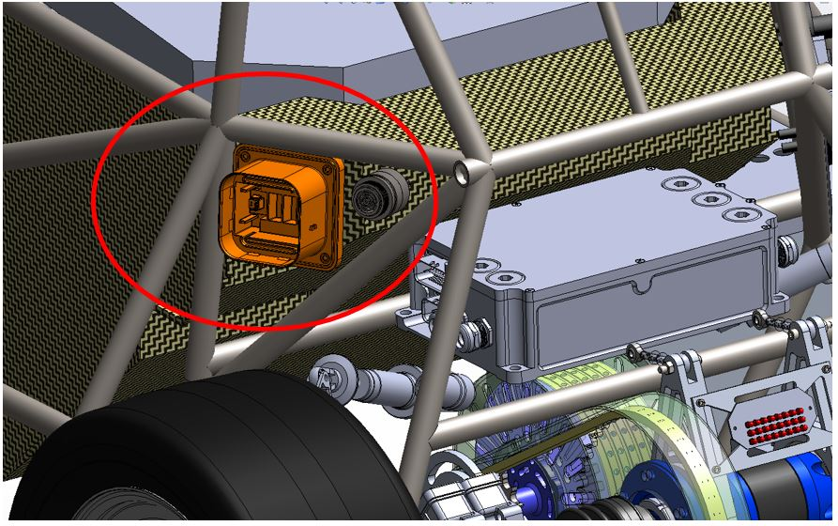

Figure 23 HVD placement

## Tractive system active light (TSAL)

### Description/circuitry

The TSAL consists of 16 100 Lumen LED’s mounted every 45 degrees to form an octagon with 2 LED’s on each side. The 3 Hz flashing frequency is driven by a 555 timer. This is turned on by a high voltage sensor set at 60V after the AIR’s (power to the motor controller) in the battery pack. (Shown below)

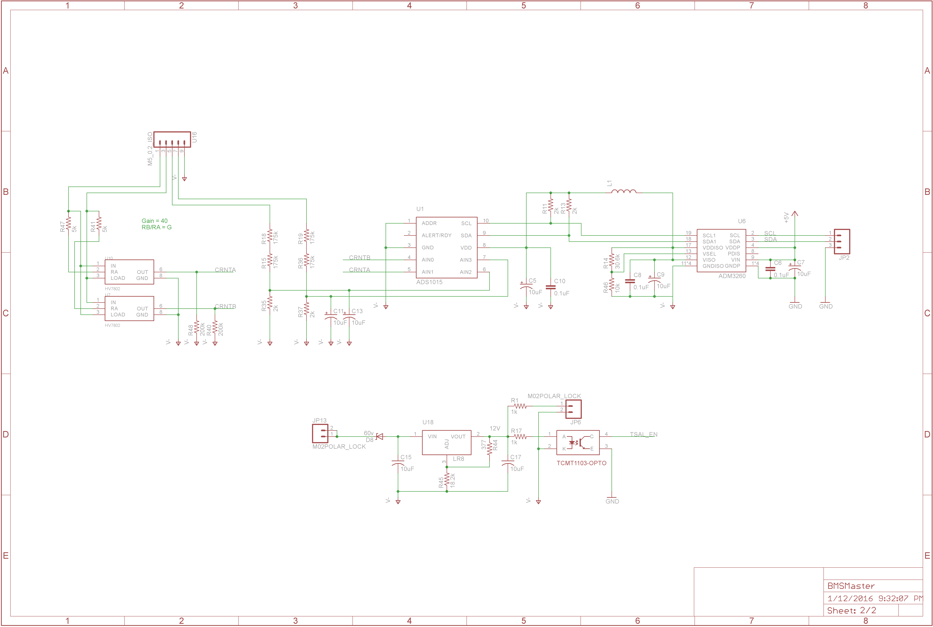

Figure 24 TSAL Control Schematic

|  |  |
| --- | --- |
| Supply voltage: | 28VDC |
| Max. operational current: | 100mA |
| Lamp type | LED |
| Power consumption: | 4.5 W |
| Brightness | 100 Lumen |
| Frequency: | 1.5Hz |
| Size (length x height x width): | 20mm x 10mm x 50mm |

Table 2.6 Parameters of the TSAL

### Wiring/cables/connectors

The TSAL uses 24 AWG PVC Insulated Hookup Wire with a 300v and 105C rating.

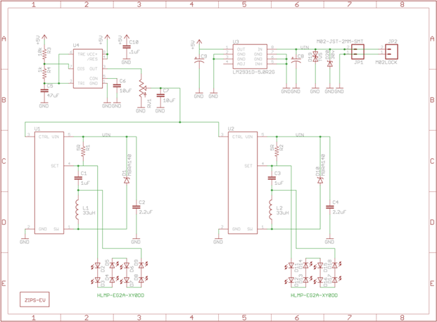

Figure 25 TSAL Schematic

### Position in car

The TSAL is mounted to the bottom of the main roll hoop as required by the rules. It will be mounted with a metal bracket if necessary.

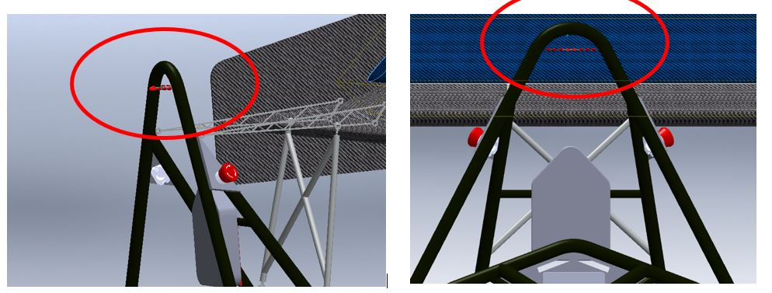

Figure 26 TSAL Posiition in Car

## Measurement points

### Description

4mm red and black banana jacks will be used to allow tractive system voltage measurement. They sit in an IP67 plastic box that has thumb screws holding on the cover. The box is UL Listed to UL508-4x, 12, & 13 specifications

TSMP Box Datasheet

TSMP Jacks Datasheet.

TSMP Resistors Datasheet



Figure 27 Tractive System Measurement Points

### Wiring, connectors, cables

The TSMP 24 AWG PVC Insulated Hookup Wire with a 300v and 105C rating will connect the banana jacks in line with a 10kOhm resistor to the HV+ and HV- connections after the AIR’s.

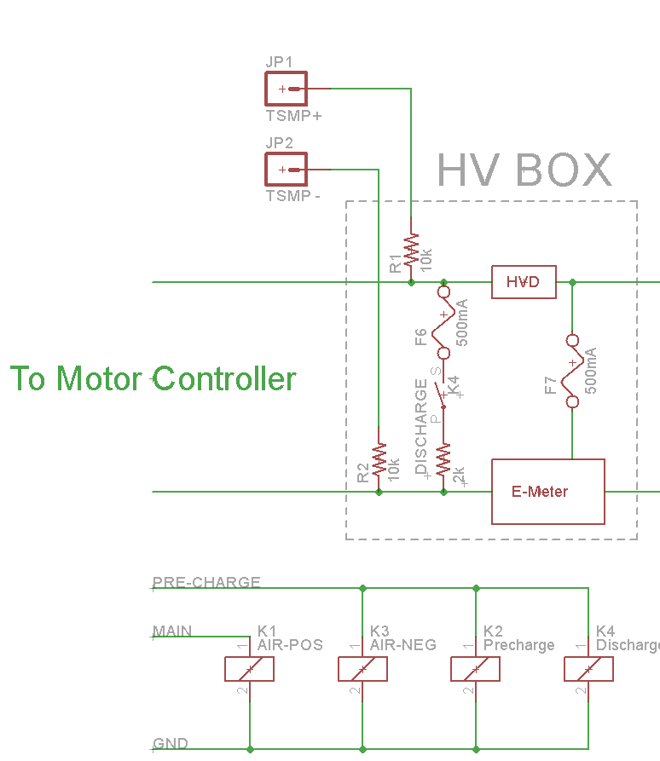

Figure 28 Tractive System Measurement Resistors

### Position in car

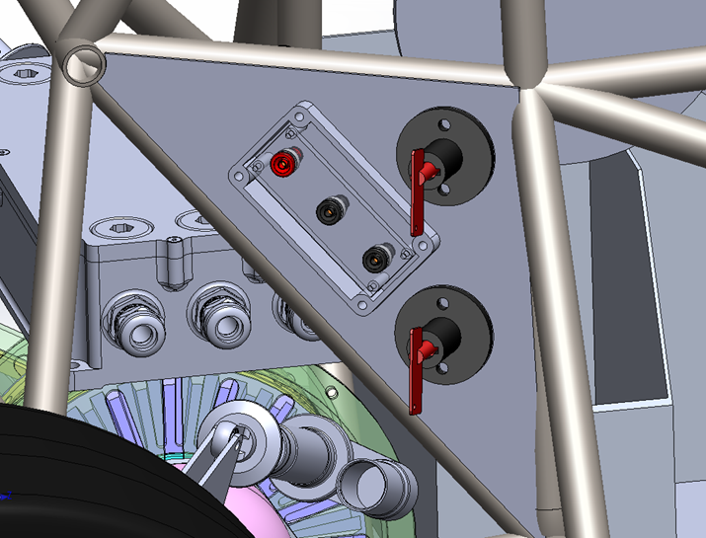

Figure 29 Tractive System Measurement Point in Car

## Pre-Charge circuitry

### Description

The Pre-Charge system of the car is used to equalize the potential of the across the AIR switch and both battery packs. Pre-Charge started when the safety system is all clear of faults. This includes the ECU clearing its fault and setting the ready to drive relay. Bottom or negative relay turns on with the Precharge High Voltage Relays in series with two 150 Ω Precharge Resistors. The hardware then waits 2.5 seconds. This 2.5 second delay originates from the safety system board. This is set by an RC timer. After the 2.5 seconds are up, the Pre-Charge relay stays on and the AIR’s turn on shorting out the Pre-Charge resistor. During Pre-Charge, the car is acquiring data from the motor controller to verify voltage is present and increasing on the battery input to the device. If this doesn’t happen, the car will trip ECU safety stop and report an error code. The Control circuitry is not near the high voltage.

### Wiring, cables, current calculations, connectors

Describe wiring, show schematics, describe connectors and cables used and show useful data regarding the wiring.

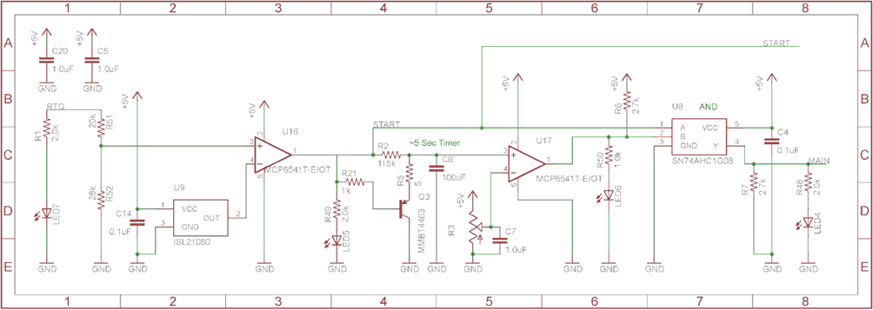

Figure 30 Pre-Charge Schematic

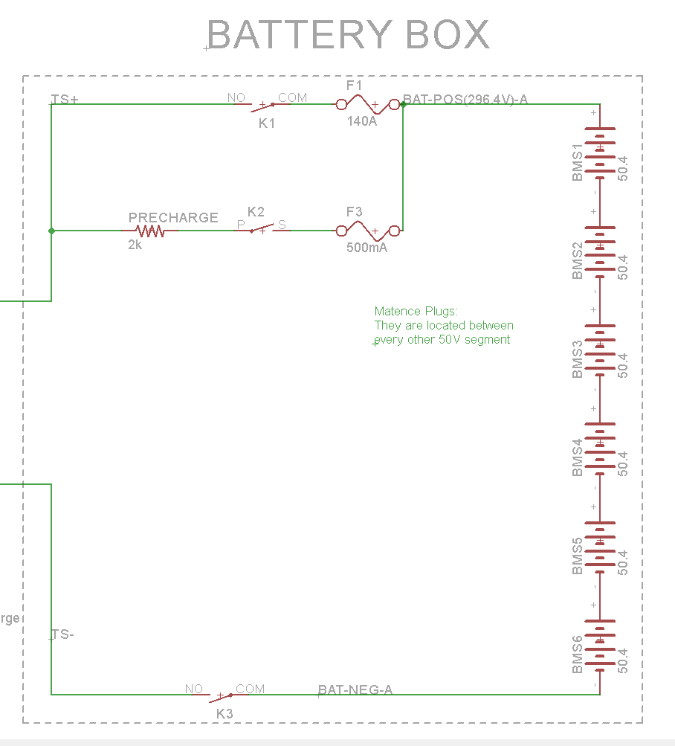

Figure 31 Pre-Charge Schematic 2

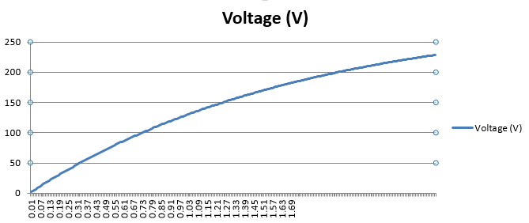

Figure 32 Pre-Charge Graph

Formula = $1-{294.2}^{\frac{-t}{150*0.00088}}$

|  |  |
| --- | --- |
| Resistor Type: | WFH160L150JE - Wirewound |
| Resistance: | 150Ω |
| Continuous power rating: | 160W |
| Overload power rating: | 160W |
| Voltage rating: | 600V |
| Cross-sectional area of the wire used: | 1.31mm² |

Table 2.7 General data of the pre-charge resistor

|  |  |
| --- | --- |
| Relay Type: | DAR72410P |
| Contact arrangment: | SPST-NO |
| Continuous DC current: | 3A |
| Voltage rating | 1000VDC |
| Cross-sectional area of the wire used: | 1.31mm² |

Table 0.1 General data of the pre-charge relay

### Position in car

Provide CAD-renderings showing all relevant parts. Mark the parts in the rendering, if necessary.

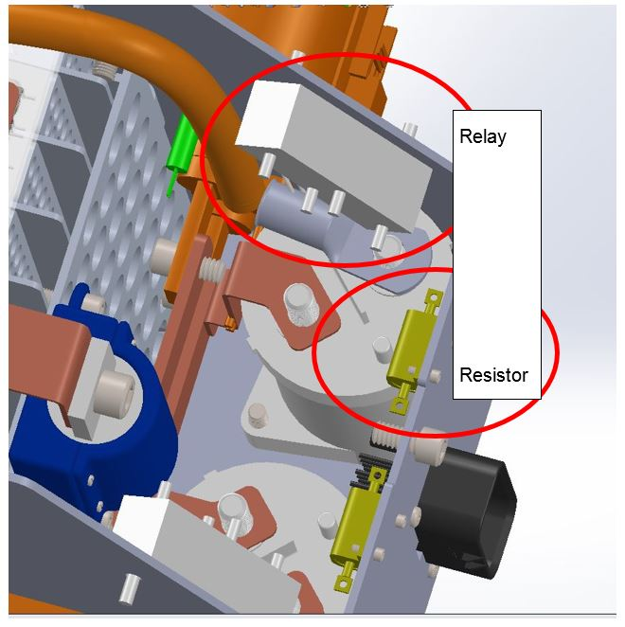

Figure 33 Pre-Charge Relay and Resistor Positions

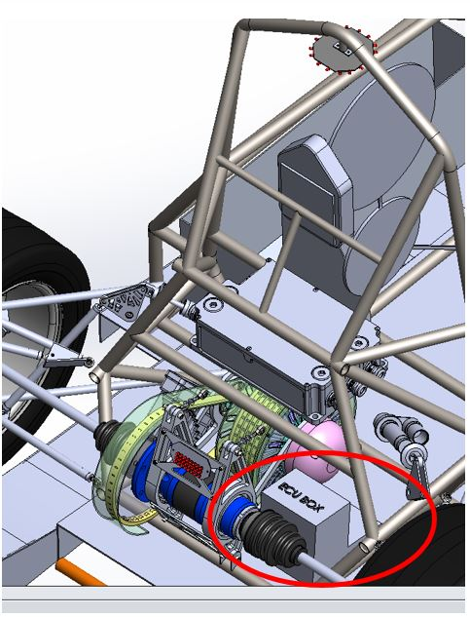

Figure 34 Pre-Charge Control Position

## Discharge circuitry

### Description

Our system requires a discharge system to get the capacitive energy out of the motor controller. Our system uses Discharge Resistors to drop the energy. We are able to discharge the energy in about 1.8 seconds. This circuit works off of the inverted precharge system relay (Discharge Relays) output. It works by being a normally closed relay shorting the output of the accumulators and only opens when the precharge system activates and main AIRs open.

### Wiring, cables, current calculations, connectors

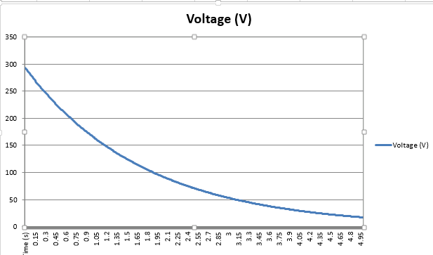

Figure 35 Discharge Voltage Graph

Formula = $\frac{295.2}{450}{2.7182}^{\frac{-t}{150*0.00088}}$

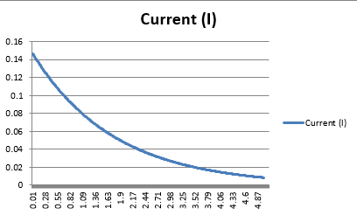

Figure 36 Discharge Current Graph

Formula = $294.2*{2.7182}^{\frac{-t}{150*0.00088}}$

Current = $295.2\frac{294V}{3300 ohms}*2.7182\frac{-t}{150*0.00088}$

Max Discharge current: 90mA Max Discharge wattage 26W



Figure 37 Discharge Circuit

See figure above (Figure 38)

Figure 38 Discharge Circuit Position in Tractive Electrical System

|  |  |
| --- | --- |
| Resistor Type: | UAL10-2KF8 - Wirewound |
| Resistance: | 2kΩ |
| Continuous power rating: | 12.5W |
| Overload power rating: | 62.5W |
| Voltage rating: | 1500V |
| Maximum expected current: | 146mA |
| Average current: | 48mA |
| Cross-sectional area of the wire used: | 1.31 mm² |

Table 0.1 General data of the discharge circuit

|  |  |
| --- | --- |
| Relay Type: | DBR72410P |
| Contact arrangment: | SPST-NC |
| Continuous DC current: | 3A |
| Voltage rating | 1000VDC |
| Cross-sectional area of the wire used: | 1.31 mm2 |

Table 0.10 General data of the dis-charge relay

Resistor datasheet

Relay datasheet

### Position in car

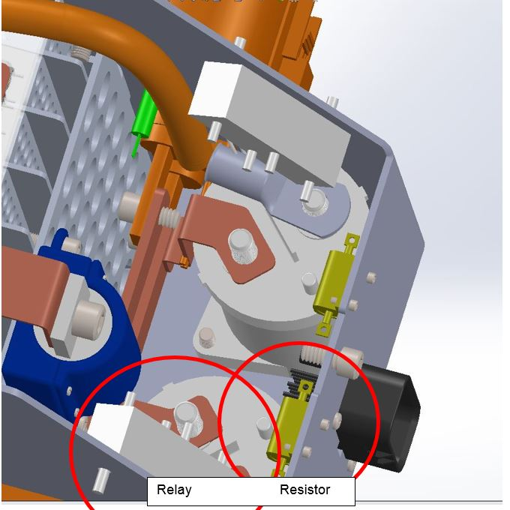

Figure 39 Discharge Relay & Resistor Position

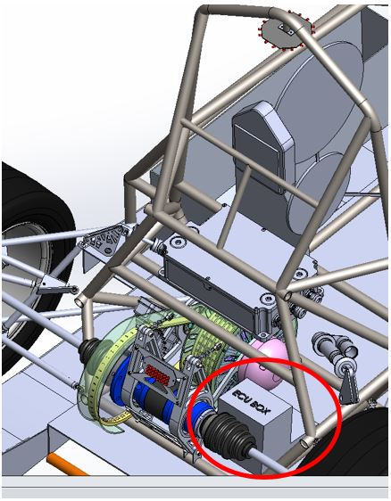

Figure 40 Position of Control Circuitry in Car

## HV Disconnect (HVD)

### Description

The High Voltage Disconnect is a 1-1587987-7 model from TE connectivity. It is a member of their Series B connector family and is capable of 630Amps and 450V. It is disconnected by a pull handle.

### Wiring, cables, current calculations, connectors

Wire - EXRAD-FSX1X 1 couple.



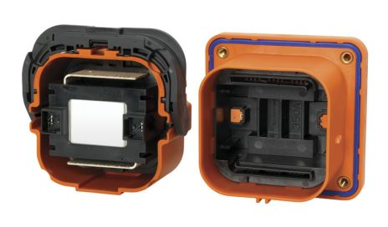

Figure 41 HVD Connector

### Position in car

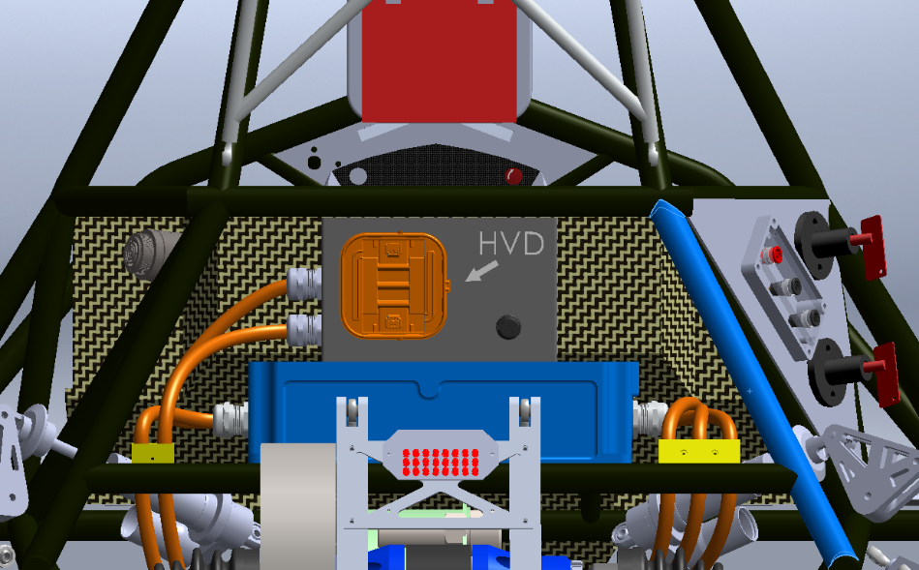

Figure 42 HVD Position in Car

## Ready-To-Drive-Sound (RTDS)

### Description

Upon the Accumulator Isolation Relays closing, and the motor controllers turning on, a 24V car horn will turn on for more than one second and less than three to notify all that the vehicle is ready to drive. The Ready to Drive Horn (Mallory PT-4632PLQ) is driven by a mosfet driver. The signal that drives the buzzer is from the ECU with software. The horn is capable of generating 83bBA at 2 meters.

### Wiring, cables, current calculations, connectors

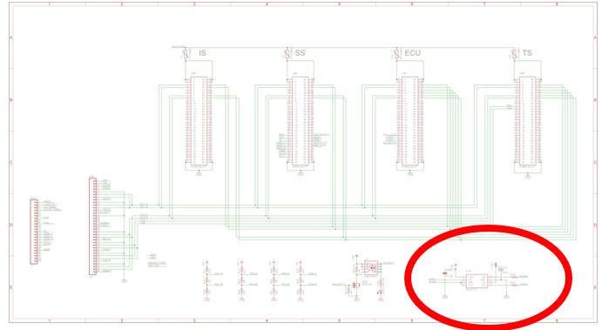

Figure 43 Horn Control Circuitry

The Horn uses 24 AWG PVC Insulated Hookup Wire with a 300v and 105C rating. There are no connectors for the Horn. **Error! Reference source not found.** datasheet

### Position in car

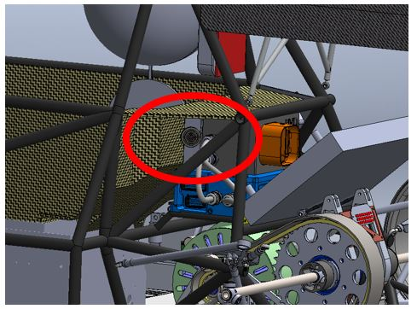

Figure 44 Horn Position in Car

# Accumulator

## Accumulator pack 1

### Overview/description/parameters

|  |  |
| --- | --- |
| Maximum Voltage: | 294VDC |
| Nominal Voltage: | 231VDC |
| Minimum Voltage: | 203VDC |
| Maximum output current: | 580A for 2s |
| Maximum nominal current: | 280A |
| Maximum charging current: | 28A |
| Total numbers of cells: | 210 |
| Cell configuration: | 70s3p |
| Total Capacity: | $$Capacity\left[MJ\right]=\left[Ah\right]×Voltage\left[V\right]×\# of cells*3600\left[\frac{s}{h}\right]×{10}^{-6}[\frac{MJ}{J}]$$ 21.6 MJ |
| Number of cell stacks < 120VDC | 5 |

Table 3.1 Main accumulator parameters

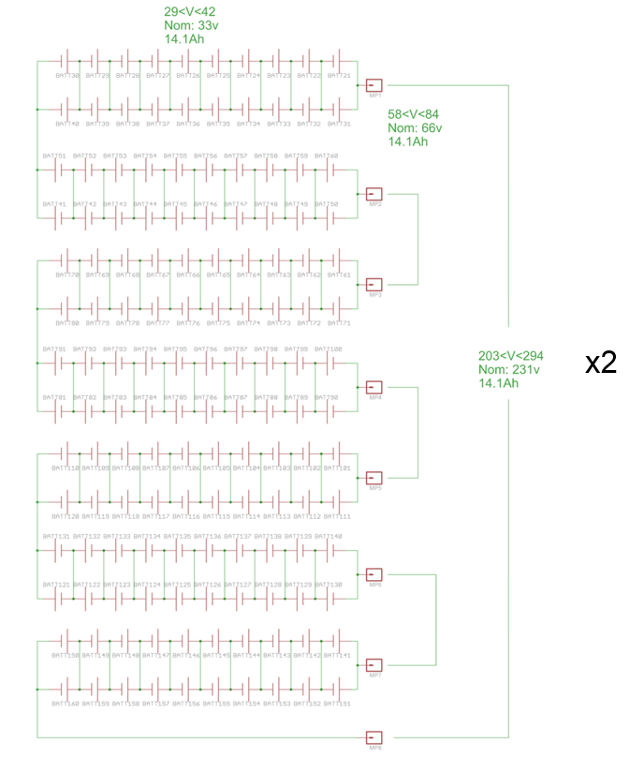

Figure 45 Accumuluator Battery Layout

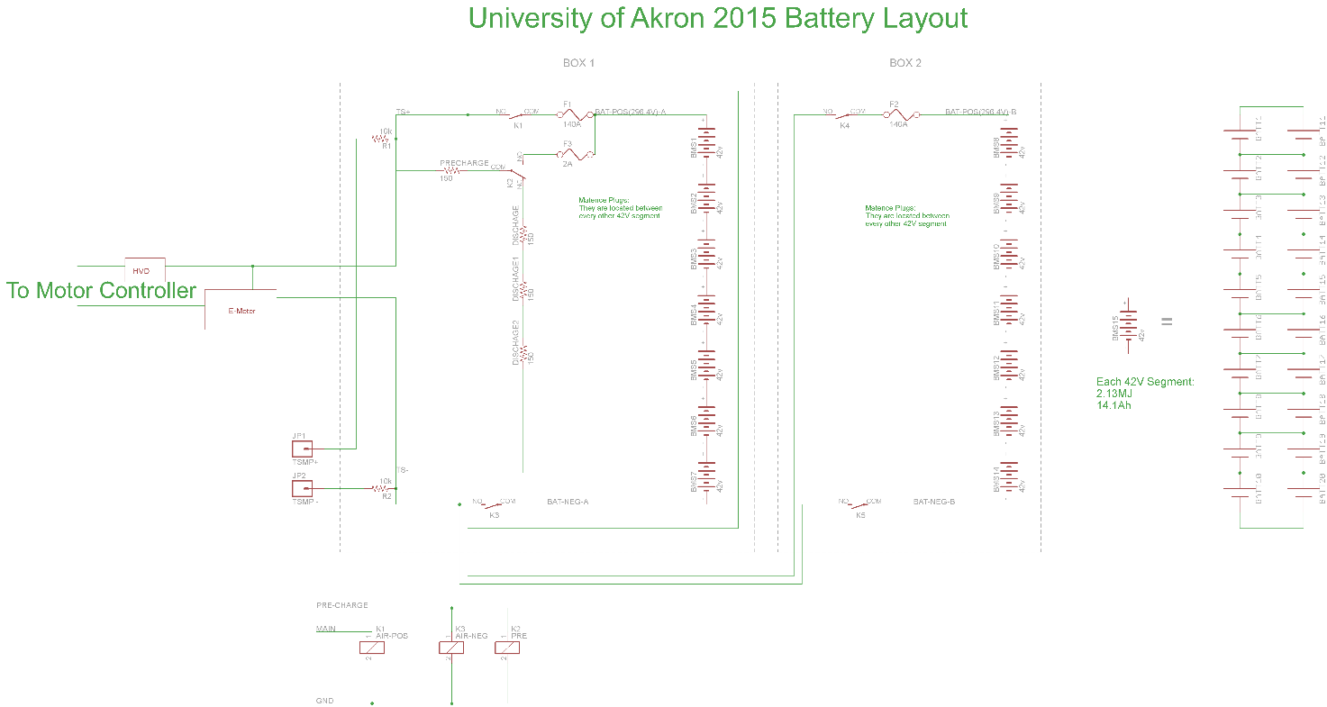

Figure 46 Accumulator Battery Layout (High Level)

Right (Box1-70s2p)

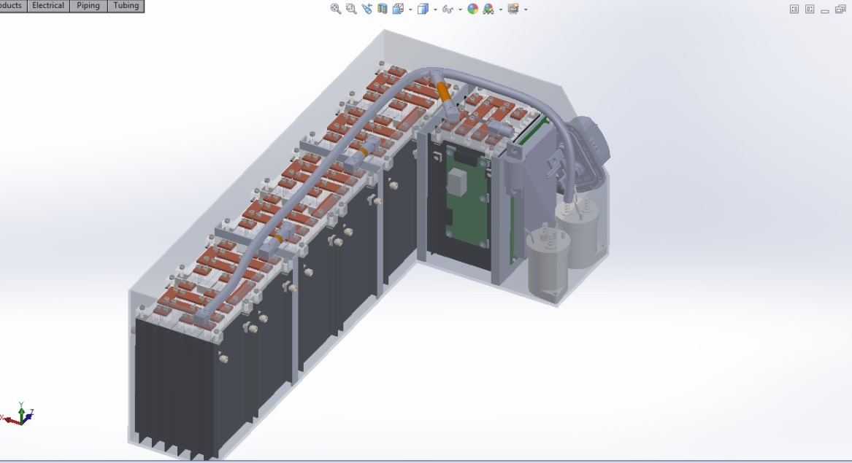

Figure 47 Accumulator Box Right (Box1-70s2p)

Left (Box2-70s2p)

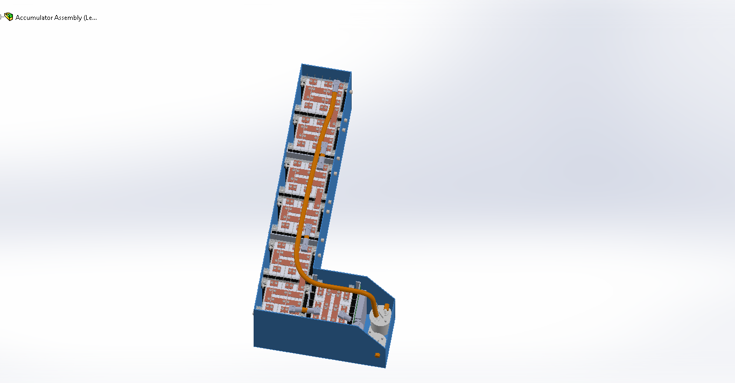

Figure 48 Accumulator Box Left (Box2-70s2p)

Modules (10s2p) x7 per container ~42v

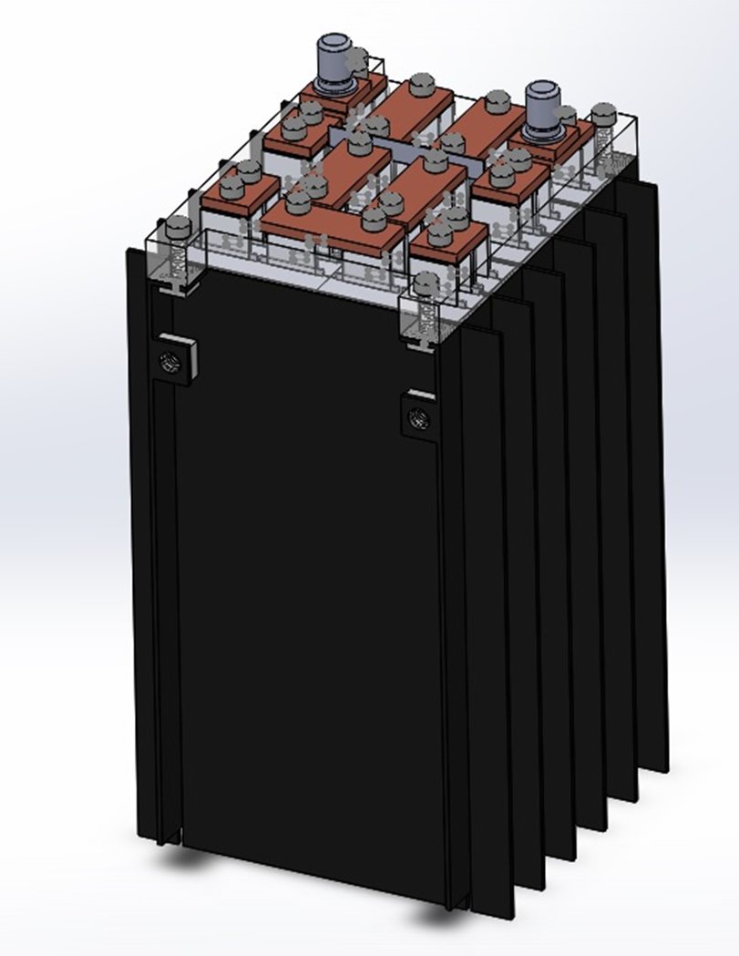

Figure 49 Battery Pack Modules (10s2p) x7 per container ~42v

### Cell description

|  |  |
| --- | --- |
| Cell Manufacturer and Type | Melasta SLPB9145180 |
| Cell nominal capacity: | 7.05 Ah |
| Maximum Voltage: | 4.2 V |
| Nominal Voltage: | 3.3V |
| Minimum Voltage: | 3.0V |
| Maximum output current: | 25C for 10s |
| Maximum nominal output current: | 20C |
| Maximum charging current: | 2C |
| Maximum Cell Temperature (discharging) | 60°C |
| Maximum Cell Temperature (charging) | 45°C |
| Cell chemistry: | LiPo |

Table 3.2 Main cell specification

### Cell configuration

Each accumulator contains 140 cells. The cells are separated in 7 segments containing 20 cells each. The segments are in a 10s2p arrangement. Each parallel cell in the segment is back to back. The cells are connected together by clamping custom copper bus bar on top of the tabs. This is shown in above figure.

### Cell temperature monitoring

Every cell will be monitored for temperature. We do this by putting an NTC resistor on the negative cell buss bar and fed back in to the battery management slave microcontroller.

### Battery management system

280 cells will be monitored by the BMS that we made ourselves. 14 Slave devices with microcontrollers will communicate with one Master. This communication is done over RS485 and is isolated at each cell and master. The BMS is capable of opening a relay in the shutdown circuit to open the AIRs in the case of an error. At a minimum cell voltage of 3.8 and a maximum of 4.2, the BMS will take actions to bypass the affected cell(s). The BMS also reacts to problems as follows: Short cell (0v), blown fuse (2.5v biases present), and Over 60 degrees C. These all end in a safety shutdown by removing power to the AIRs. The BMS can also measures current with a high side current shunt with orange wire. The BMS shuts down the tractive system via a relay that is tied into the safety loop. That would trip the safety system and the car would shut down. These boards are linked with locking Molex connectors. This allows for hot swapping boards. The slave boards are mounted to the sides of the modules. There is wire going between the BMS PCB and the Battery pack. We have PCB inline fuses to protect the brown BMS sense wires. (Datasheet BMS sense fuse) Isolation is on two items the BMS and the Iso board. The devices on these parts keep isolation up to 2.5 kV. (Device marked with red indicators on the schematics)

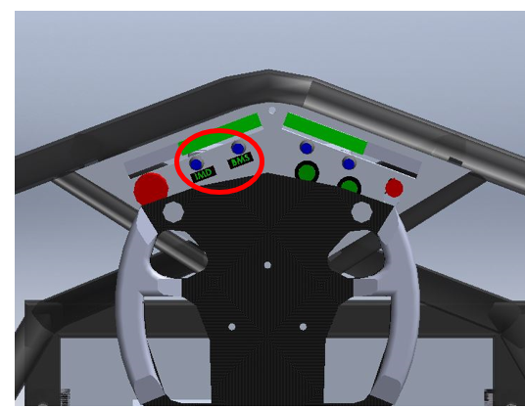

Figure 50 IMD & BMS Status Light

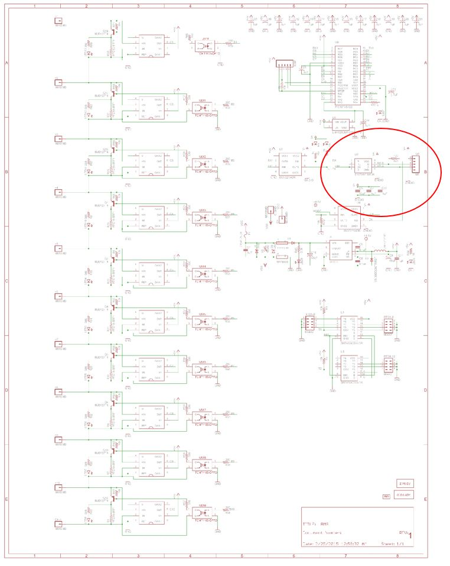

Figure 51 Battery Management Slave Schematic

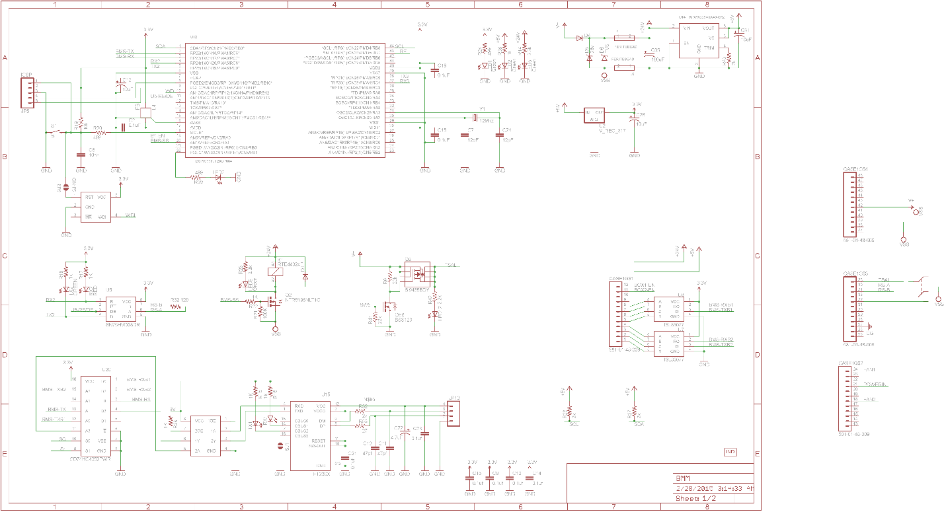

Figure 52 Battery Management Master Schematic

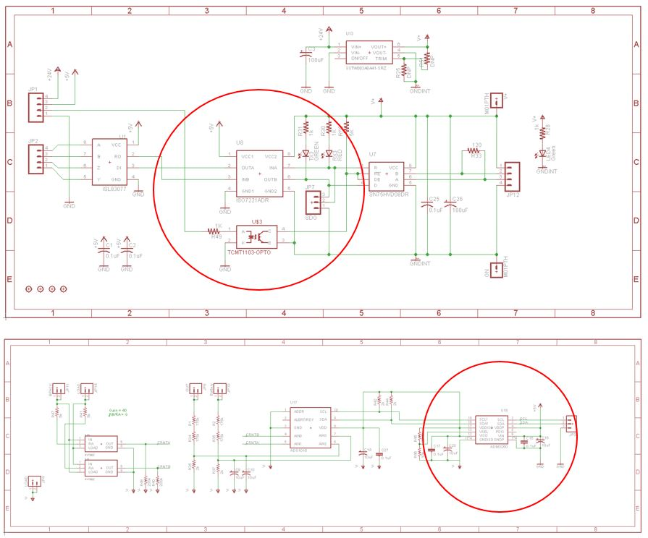

Figure 53 Battery Management Isolation Board (Master/Slave Isolation)

### Accumulator indicator

The accumulator indicator is an LED that will be attached to the battery enclosure to indicate that the pack is active. This indicator will be wired across the first and last AIR’s, so that it is powered when there is voltage on the vehicle side of the accumulator container. It therefore the circuit below is only powered from tractive system voltage. It does not run off of the GLVS and therefore work outside of the car. The wire used for this AWG 22. The circuit bellow illuminates the LED and TSAL at 60V.

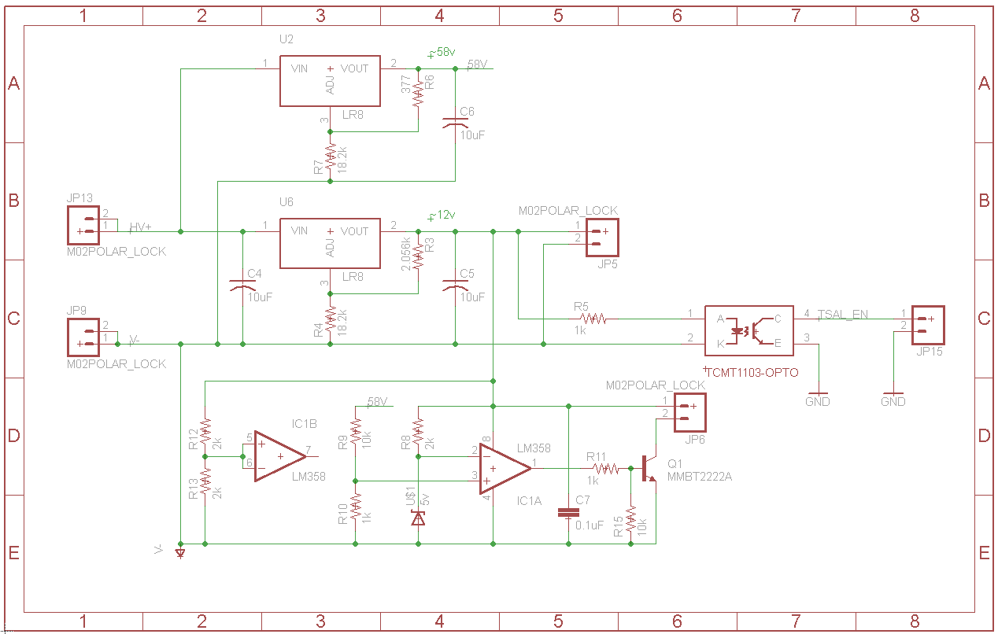

Describe the indicator, show wiring, provide tables with operation, PCB design, etc.

### Wiring, cables, current calculations, connectors

|  |  |
| --- | --- |
| Wire type | Alpha Wire 1855 (data sheet Hookup wire) |
| Continuous current rating: | 7A |
| Cross-sectional area | 0.030 in |
| Maximum operating voltage: | 300V |
| Temperature rating: | 105 °C |
| Wire connects the following components: | Cell and BMS |

Table 3.3 Accumulator Indicator hookup wire specs

GLV wire enters the black connector in photo. The wire then is bundled with high temp, high voltage rated heat shrink into a bundle going to the iso board. All high power paths are locked down with Belleville washers or lock nuts.

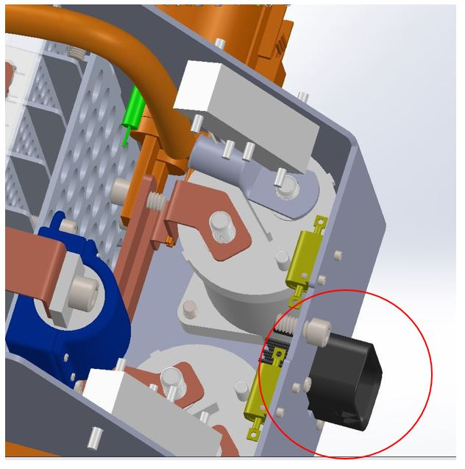

Figure 54 Accumulator Connector (Low Voltage)

### Accumulator insulation relays

Accumulator Isolation Relay Datasheet

|  |  |
| --- | --- |
| Relay Type: | EV200AAANA |
| Contact arragment: | SPST |
| Continous DC current rating: | 500A |
| Overload DC current rating: | N/A |
| Maximum operation voltage: | 900VDC |
| Nominal coil voltage: | 24VDC |
| Normal Load switching: | Make and break up to 500A |
| Maximum Load switching | 10 times at 1500A |

Table 3.4 Basic AIR data

### Fusing

We use one main fuse in the car, which fuses the outputs of the accumulator container. The HV Fuse Holder holder we are using is the LSCR001 from little fuse. It is rated for 600v and 400A, and also has UL fire rating.

|  |  |
| --- | --- |
| Fuse manufacturer and type: | Littelfuse, Class T |
| Continous current rating: | 150A |
| Maximum operating voltage | 300VDC |
| Type of fuse: | High speed |
| I2t rating: | 1500A2s at 450VDC |
| Interrupt Current (maximum current at which the fuse can interrupt the current) | 20000A |

Table 3.5 Basic fuse data

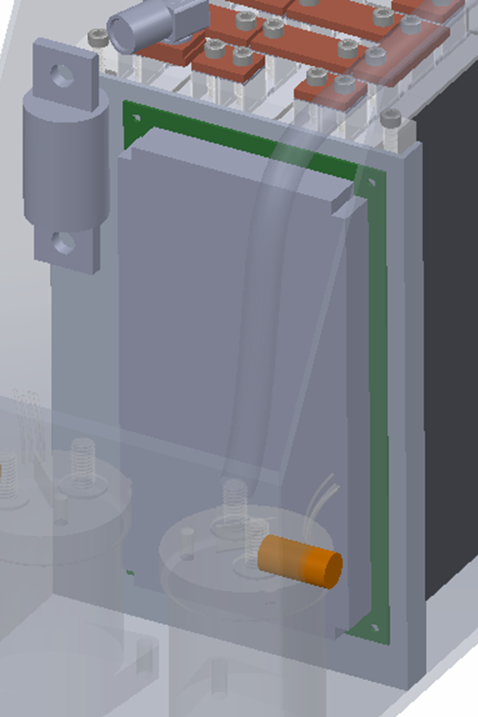

Figure 55 Accumulator Fusing

|  |  |  |  |  |
| --- | --- | --- | --- | --- |
| Location | Wire Size | Wire Ampacity | Fuse type | Fuse rating |
| Cells to AIRs | 2 AWG | 255 | 2x MNO Fuse | 145 |
| AIR to Motor controller | 2 AWG | 255 | N/A | N/A |
| AIR to TSAL | 24 AWG | 3.5 | EFG Fuse | XXX |
| Accumulator output connector | 2 AWG | 300 |  |  |
| Cells to BMS | 22 | 7 |  |  |

Table 3.6 Fuse Protection Table

### Charging

The battery charging will use the battery management system to control the charger. The BMS-master by default is not able to talk to the charger directly and control the AIR's. We designed a charging control adapter board that hosts the interfaces and isolation necessary to follow the rules of the competition. This board also hosts the safety system for the IMD, control relays, lights and LCD display. The Charger is a kit we assembled and tested.

|  |  |
| --- | --- |
| Charger Type: | ElectricMotorWerks SmartCharge 12000 |
| Maximum charging power: | 12kW |
| Maximum charging voltage: | 350V |
| Maximum charging current: | 70A |
| Interface with accumulator | serial communication |
| Input voltage: | 120-230 VAC |
| Input current: | Up to 50A |

Table 3.7 General charger data

### Mechanical Configuration/materials

The accumulator consists of a single container housing all the tractive system battery cells, battery management boards, and AIRs. The single L-shape container is fabricated from steel or aluminum (following EV 3.4.6 ), is marked with HV warning stickers, and contains a single Molex HV connector. The only other entry into the accumulator is the air duct, which has several baffles to prevent water intrusion. The bottom of the accumulator container is flared out to make a flange, which allows the accumulator to be bolted to the frame of the car. The accumulator container is positioned behind the driver and the firewall and is in front of the front roll hoop. The container was designed with minimizing the number of internal fasteners in mind. The lid bolts onto the accumulator container and fully seals off the HV from water and foreign objects.

The battery pack consists of 5 segments/modules (<6MJ) that are separated by aluminum walls. In order to isolate each segment, the aluminum dividers are covered in an envolope of IG Formex. Additionally, the inside walls of the accumulator container are covered with Formex and attached using Kapton tape. Figure 57 shows a single battery module, which consists of 3 parallel strings of 14 parallel batteries, a metal mounting/compression structure, and a battery management board. The battery tabs are connected together using copper bus bar, with the tabs and bus bar captured between two layers of acrylic (See Figure XX). Bus bar dimensions (XX by XX by XX) were determined using formulas which account for expected current and material properties.

Each battery module uses an in house designed toolless maintenance plug to satisfy the 6MJ/120V limit. These maintenance plugs use Rapid Lock Quick connect 6648223-1 from TE with a heat shrink boot to cover up the connector.

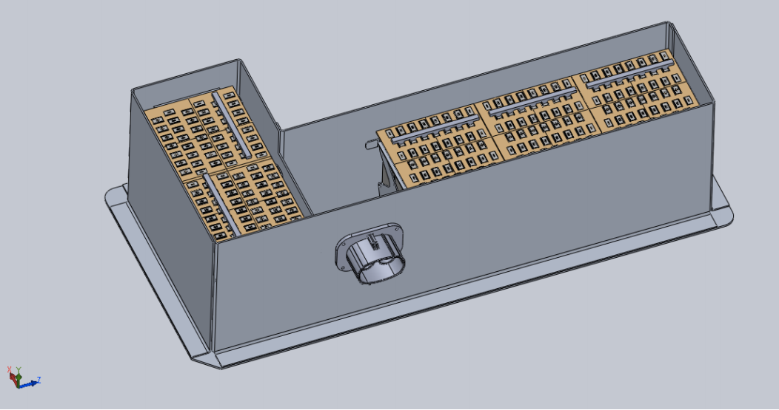

Figure 56. Full Accumulator Pod

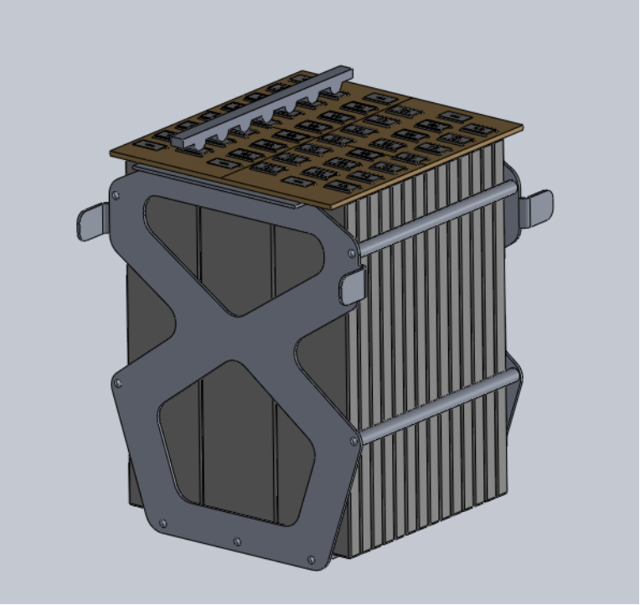

Figure 57. Accumulator Battery Module (<6MJ)

### Position in car

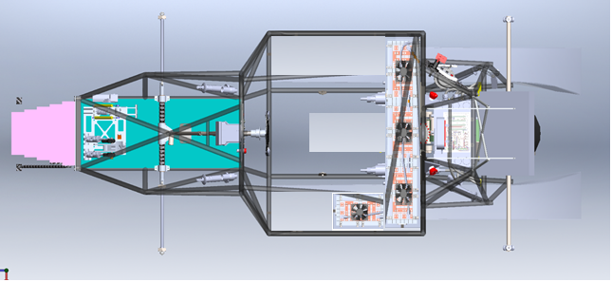

Figure 58. Accumulator Position in Car

## Accumulator pack 2

Only 1 accumulator will be used in the car.

# Energy meter mounting

## Description

## Wiring, cables, current calculations, connectors

## Position in car

# Motor controller

## Motor controller 1

### Description, type, operation parameters

The motor controller(s) used on this car is a Rinehart Motion Systems PM100DX permanent magnet brushless AC motor controller. It is capable of 0-360V and 300Arms. The motor controller is commanded via analog signals sent by our self-designed motor controller PCB (MCS). It communicates over a RS485 communication bus from the ECU. The motor controller also control the regenerative braking of the car. This is set from hardware controlled by our software. The controller is isolated. Because of that, nothing connecting to them needs isolated from chassis ground.

|  |  |
| --- | --- |
| Motor controller type: | Rinehart Motion Systems PM100DX brushless AC |
| Maximum continous power: | 108kW |
| Maximum peak power: | 126kW for 30s |
| Maximum Input voltage: | 360VDC |
| Output voltage: | 250VAC |
| Maximum continuous output current: | 300Arms |
| Maximum peak current: | 350Arms for 30s |
| Control method: | analog signal |
| Cooling method: | water |
| Auxiliary supply voltage: | 12VDC |

Table 5.1 General motor controller data

### Wiring, cables, current calculations, connectors

All connections to the accumulator, the motors, and the energy meter are all EXRAD Shielded Cable XLE 2 cable. The motor controller will do all of our shield grounding for us on the High power cable. They go through grounding cable glands. This makes a sealed connection. The conductor is clampe in a bus bar in the motor controller.

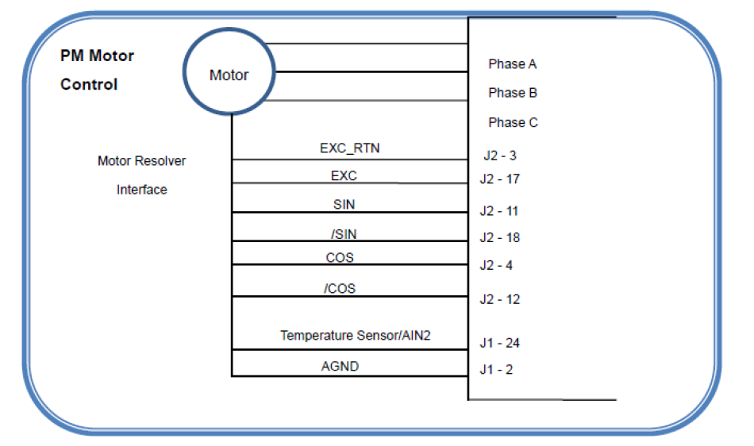

Figure 59 Motor Controller Wiring Diagram

|  |  |
| --- | --- |
| Wire type: | Champlain EXRAD Shielded Cable xlx2x |
| Current rating: | 255A |
| Maximum operating voltage: | 1000V |
| Temperature rating: | 240 °C |

Table 5.2 Wire data of Champlain Exrad Shielded Cable

### Position in car

The motor controller is position in the rear of the car (behind the main roll hoop) above the motor.

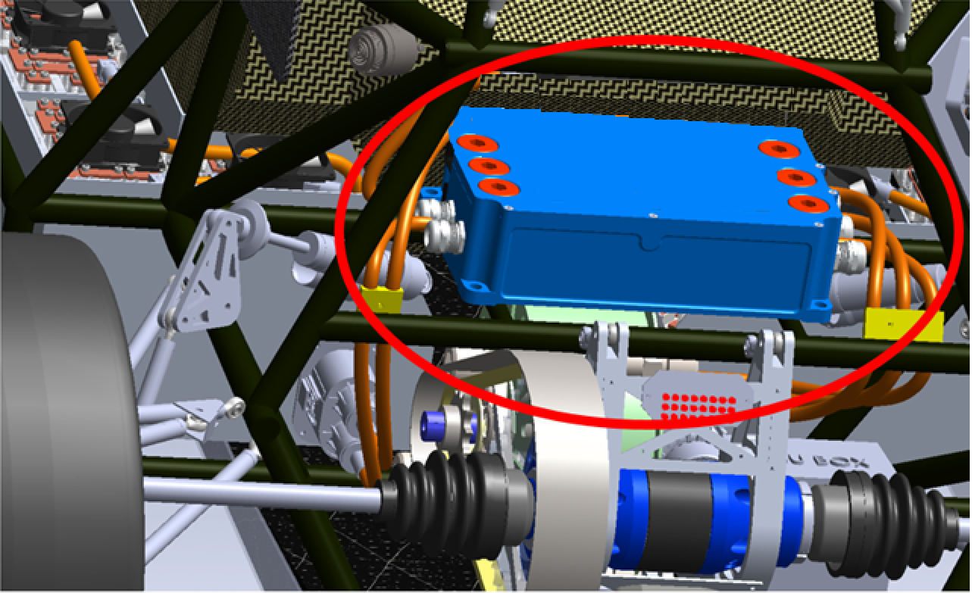

Figure 60 Motor Controler Position in Car

## Motor controller 2

…

This vehicle only uses 1 motor and 1 motor controller

.

# Motors

## Motor 1

### Description, type, operating parameters

|  |  |
| --- | --- |
| Motor Manufacturer and Type: | Enstroj EMRAX228 HV |
| Motor principle | Brushless Synchronus Three Phase AC |
| Maximum continuous power: | 45kW |
| Peak power: | 100kW for 3s |
| Input voltage: | 50-600Vdc |
| Nominal current: | 115A |
| Peak current: | 240A |
| Maximum torque: | 240Nm |
| Nominal torque: | 125Nm |
| Cooling method: | Water |

Table 6.1 General motor data

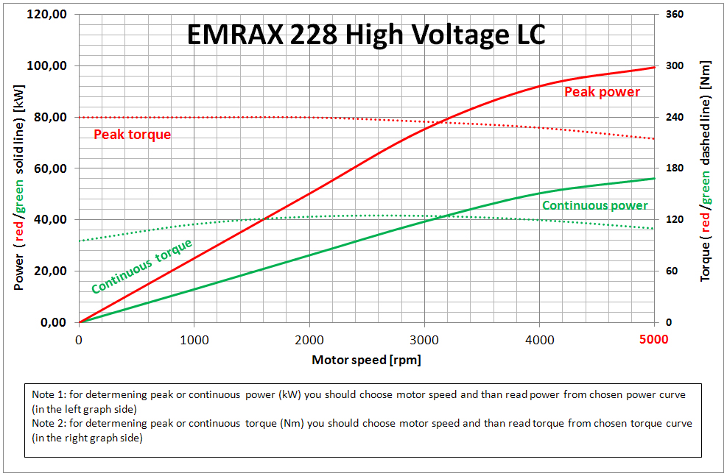

Figure 61 Motor Torque/Speed & Power/Speed Data

### Wiring, cables, current calculations, connectors

The three shielded wires coming to the motor have 90 degree crimp terminals and then bolted on to the connections to the motor. We are adding locking nuts to prevent looseness of the connection. We are 3D printing a cover that goes over these terminals to provide isolation spacing and protect people. Additionally strain relief and vibration isolation will be achieved by adding grommets in the 3D printed cover.

### Position in car

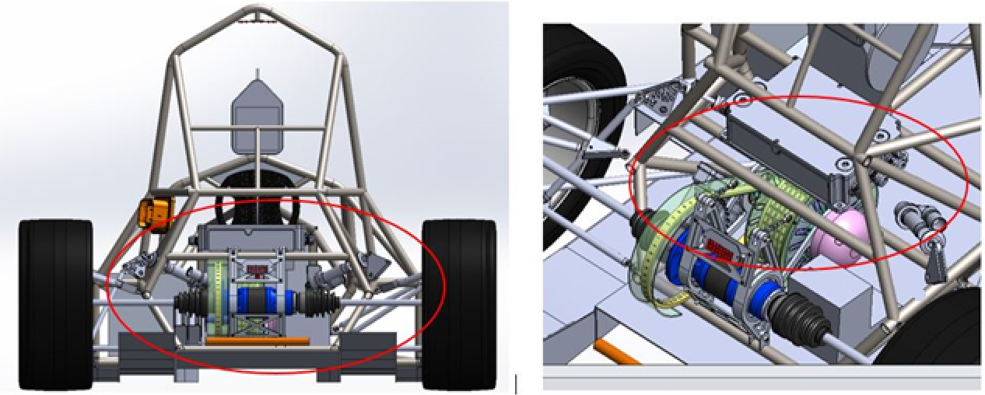

**MOTOR**

**MOTOR**

Figure 62 Motor Position in Car (Rear & Isometric View)

## Motor 2

…

This vehicle only uses 1 motor.

# Torque encoder

## Description/additional circuitry

The two CLS1322-075 sensors are linear displacement sensor. They will be connected to the throttle pedals of the vehicle. As the pedal moves the sensor will slide with the pedal and provide an analog output to the system. That output will be sent as an input to a conditioning circuit. Once conditioned, the signal will be sent to the main controller.

|  |  |
| --- | --- |
| Torque encoder manufacturer and type: | CLS1322-075 |
| Torque encoder principle: | potentiometer |
| Supply voltage: | 3.3V |
| Maximum supply current: | 20mA |
| Operating temperature: | -20..180 °C |
| Used output: | 150mV-3.2V |

Table 7.1 Torque encoder data

## Torque Encoder Plausibility Check

If an error occurs in the measuring requested torque from the throttle pedal the main controller will shut the vehicle down. A number of errors could occur. If the communication is lost between the SAS (Where the analog signal is measured) and ECU the car will be shutdown (AIR’s opened). If at any time the conditioning circuit is shorted or becomes open the controller will see the loss of signal (30ms) and will shut the car down. If the outputs of the two potentiometers differ by more than 10% the vehicle will be shut down as stated in the rules.

We check for above failures by first, monitoring data integrity by using CRC check sums in serial data and in code. We monitor position sensors integrity by using the sensors as rheostats and adding a 5 ohm resistor in series with the sensor. We added a 100 ohm pull up on the ADC pin. With the sensor connected to the ADC pin to ground we can measure all fault modes.

The analog output to the motor controller is made created by an I2C DAC. It is buffered by an op-amp. That signal goes to a SPDT relay. The output to the motor controller is on the common pin. The DAC is connected to the NO pin. The NC pin is pulled to ground. The uC reads the DAC to verify output matched set point. If they match, the relay opens and stays open as long as the car is on and output matches set point.

## Wiring

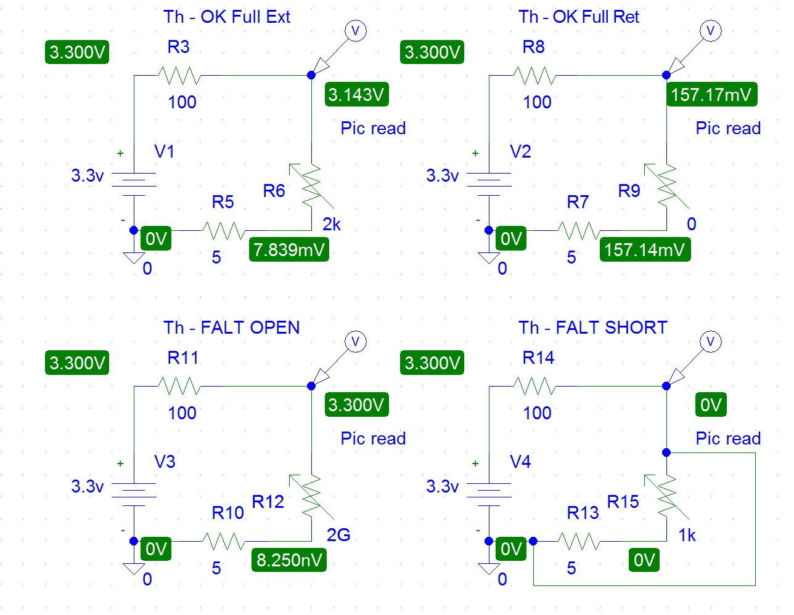

Figure 63 Throttle Sensor Fault Conditions

## Position in car/mechanical fastening/mechanical connection

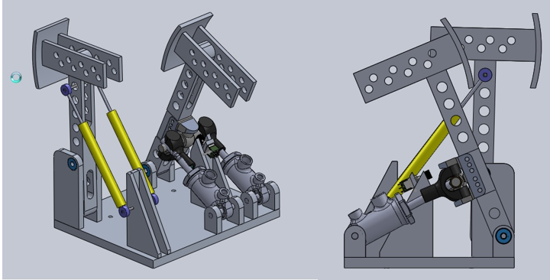

Figure 64 Throttle Pedal and Sensor Position in Car

# Additional LV-parts interfering with the tractive system

## LV part 1 – GLVS BMS

### Description

Our GLVS is powered by a custom battery pack. This pack is protected by a student designed battery management system that is from a reference design from Design Flux Technologies.

Seven cells will be monitored by the in-house fabricated BMS board. The BMS is capable of opening a relay to disconnect the pack. This removes all GLV power to the car, shutting the car down. The BMS will monitor cells for minimum voltage of 2.75v and a maximum of 4.2. Our BMS will take actions to bypass the affected cell(s) of higher voltage and shutdown the GLVS system if necessary. The BMS also reacts to temperature problems at 60°C. The BMS can also measure current and trigger the safety system. There is a wire going between the BMS PCB and the Battery pack.

### Wiring, cables,

Figure 65. GLVS Wiring and BMS circuit

### Position in car

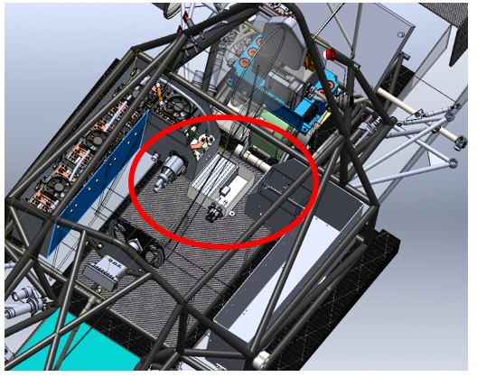

Figure 66. GLVS battery pack location in car

## LV part 2 Traction Control System

…

# Overall Grounding Concept

## Description of the Grounding Concept

The chassis is made from conductive chrome-moly and will provide low resistance paths through the frame. The steering wheel will have a ground wire thru the quick disconnect to ensure low resistance. Firewalls will be mounted to the car via tabs welded to the frame. The tabs will have paint removed to make a robust electrical connection to the firewall

## Grounding Measurements

The grounded low voltage measurement point (GLVMP) location is a frame bolt which is connected to a wire coming from the GLV battery lead. Measurements between various points and this frame bolt will be tested to ensure compliance with EV4.3.

# Firewall(s)

## Firewall 1

### Description/materials

The Tractive System Firewall serves a dual purpose of protecting the driver from potential hazard, but also supporting the driver in the car. Because the seat is molded foam and not rigidly mounted to the chassis, the firewall must be capable of supporting the driver's torso and seat throughout the dynamic events. The proposed firewall is a composite structure consisting of fire retardant materials. This allows us to make a stiff panel that is also fire resistant. The concept, attached below, consists of an aluminum skin (0.5 mm thick) facing the HV components (per the required firewall rules) and fire resistant core materials, followed by a Kevlar skin. A thick kevlar skin will be sufficient in preventing piercing of the firewall, and the honeycomb structure will give the panel enough stiffness to support the loads required. The firewall is grounded to the chassis via the mounting system used to secure it to the chassis. This consists of Socket head cap screws through the firewall and tabs welded directly to the chassis. In the event that this grounding method is not sufficient, a properly sized grounding strap will be added to the aluminum skin and attached to the chassis.

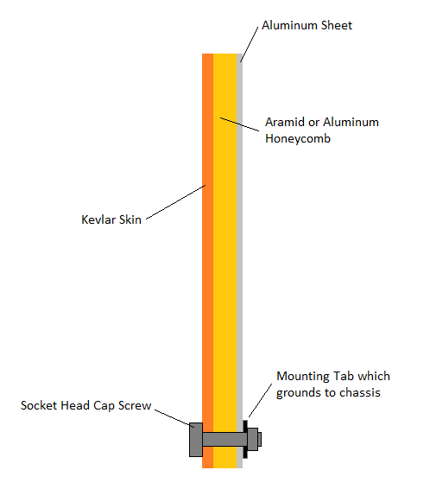

### Position in car

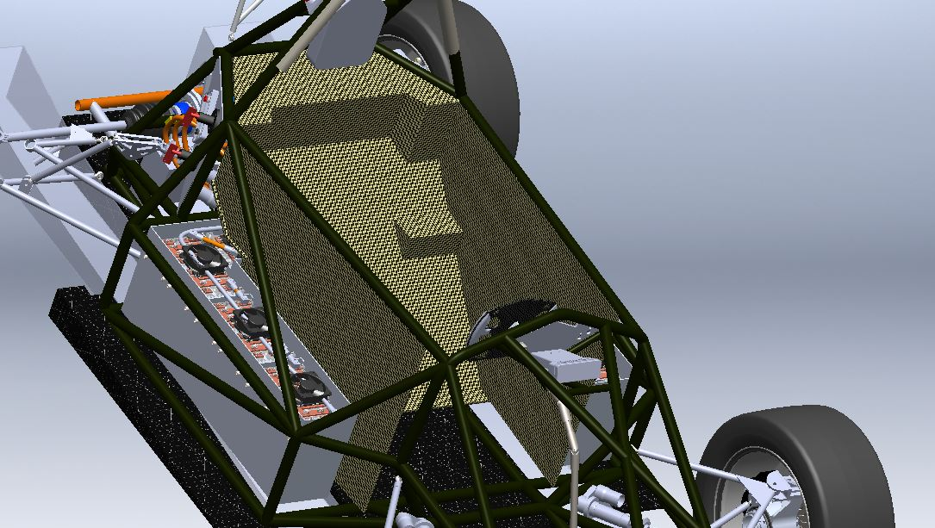

## Firewall 2

This car only has 1 firewall.

# Appendix

## System Overview

### 18 AWG PVC Insulated Hookup Wire

Referred to

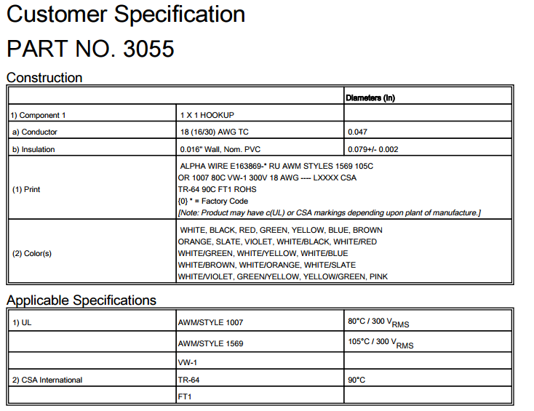

Full datasheet can be found [here](http://www.alphawire.com/en/Products/Wire/Hook-Up-Wire/Premium/3055?device=pdf)

### 24 AWG PVC Insulated Hookup Wire

Referred to :2.2.2, 2.3.3

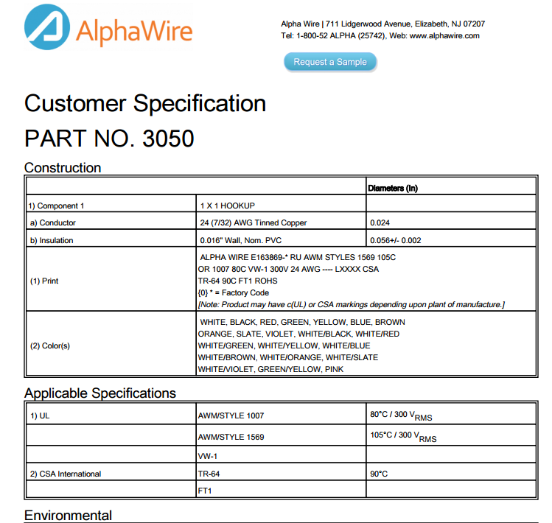

Full Datasheet can be found [here](http://www.alphawire.com/Home/Products/Wire/Hook-Up-Wire/Premium/3050?device=pdf)

### TSMS/HV Sense Wire

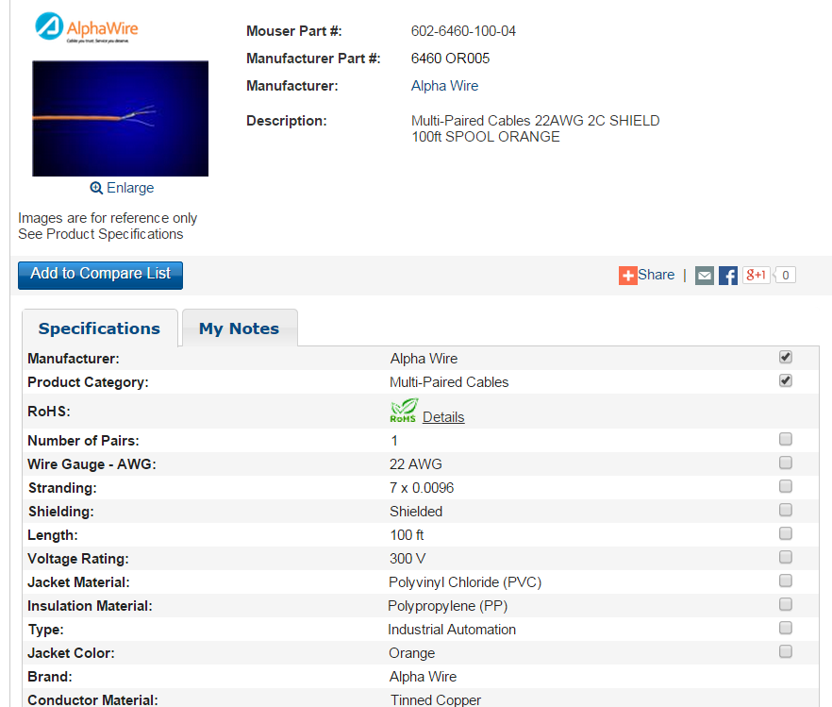

Full datasheet: [here](http://www.mouser.com/ProductDetail/Alpha-Wire/6460-OR005/?qs=sGAEpiMZZMv1%2f%252b2kKkGMBdDOvp5WNg%252bt9emRXpKWYqs%3d)

## Electrical System Datasheets

### Shutdown Circuit

#### E-Stop Switches

Referred to: 2.1.1

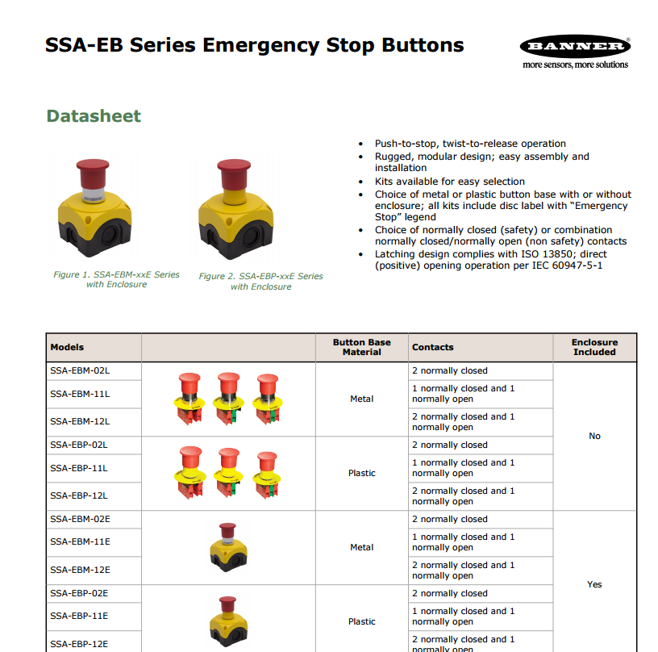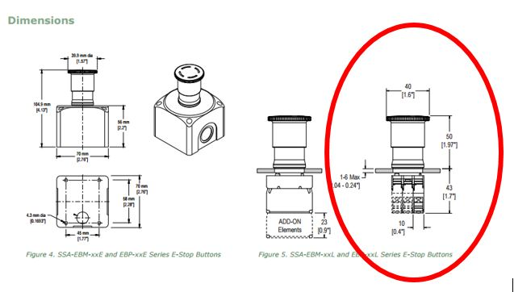

Full Datasheet: [here](http://info.bannersalesforce.com/cs/groups/public/documents/literature/111880.pdf)

#### Tractive System Master Switch

Referred to: 2.1.1

### Bender IR155-3203 IMD

Referred from 2.1.1., 2.2

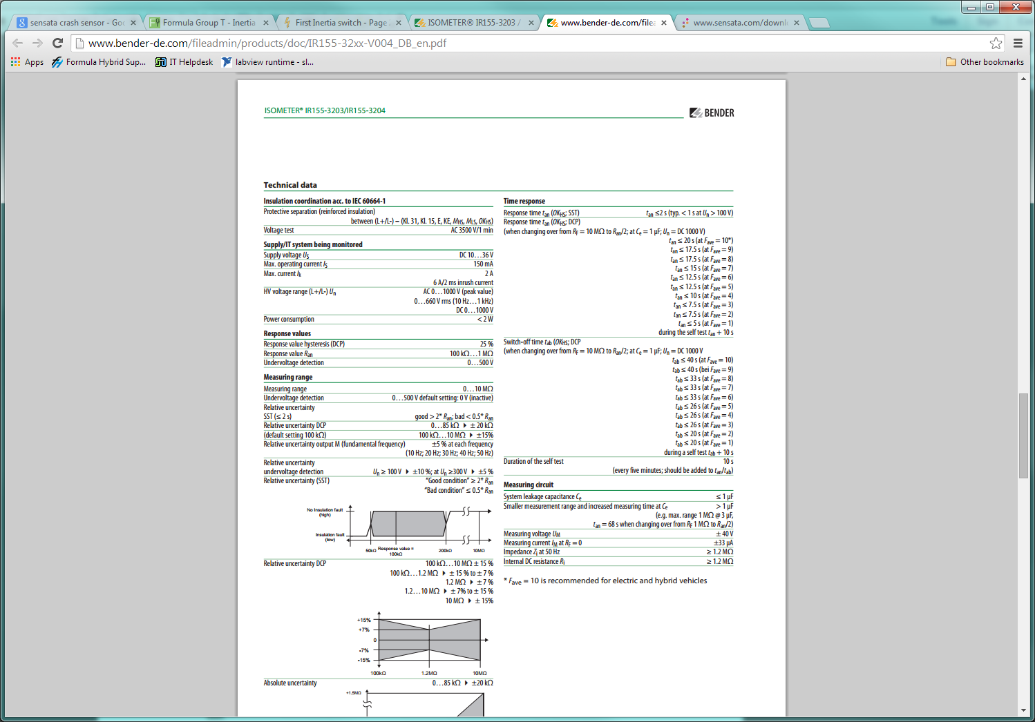

Complete data sheet located [here](http://www.bender-de.com/fileadmin/products/doc/IR155-32xx-V004_DB_en.pdf)

### Crash Sensor

#### Sensata resettable inertial switch

Referred from 2.3

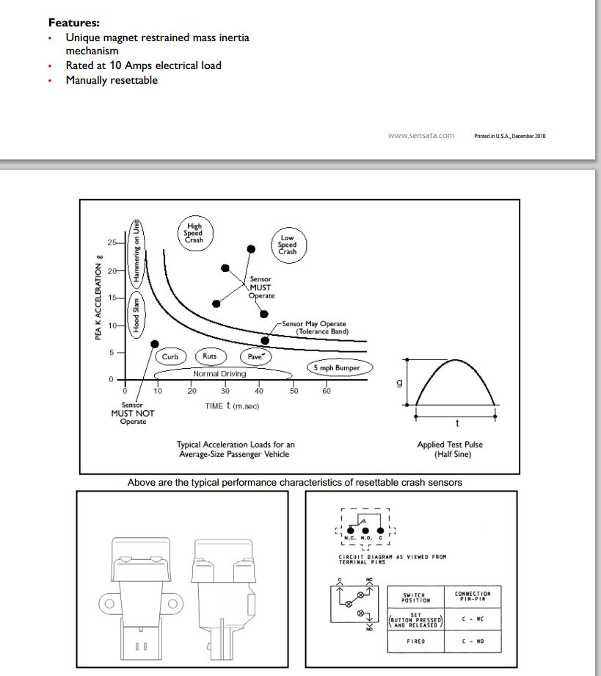

Datesheet [here](http://www.sensata.com/download/resettable-crash.pdf)

### Brake Plausibility

#### Honeywell Brake Pressure Sensor

Referred to 2.3.1

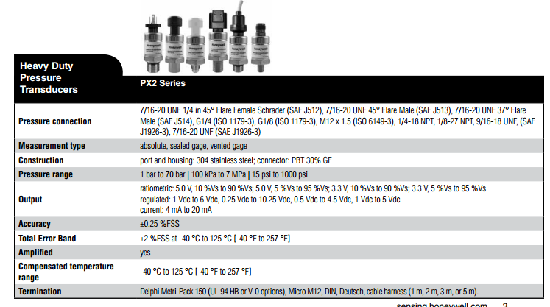

Full datasheet can be found [here](http://sensing.honeywell.com/honeywell_sensing_px2_series-productsheet_500599462-en-revg.pdf)

### IMD/BMS Reset

### Shutdown System Interlocks

### Tractive System Active Light

#### 100 Lumen LED

Referred to: 2.7.1

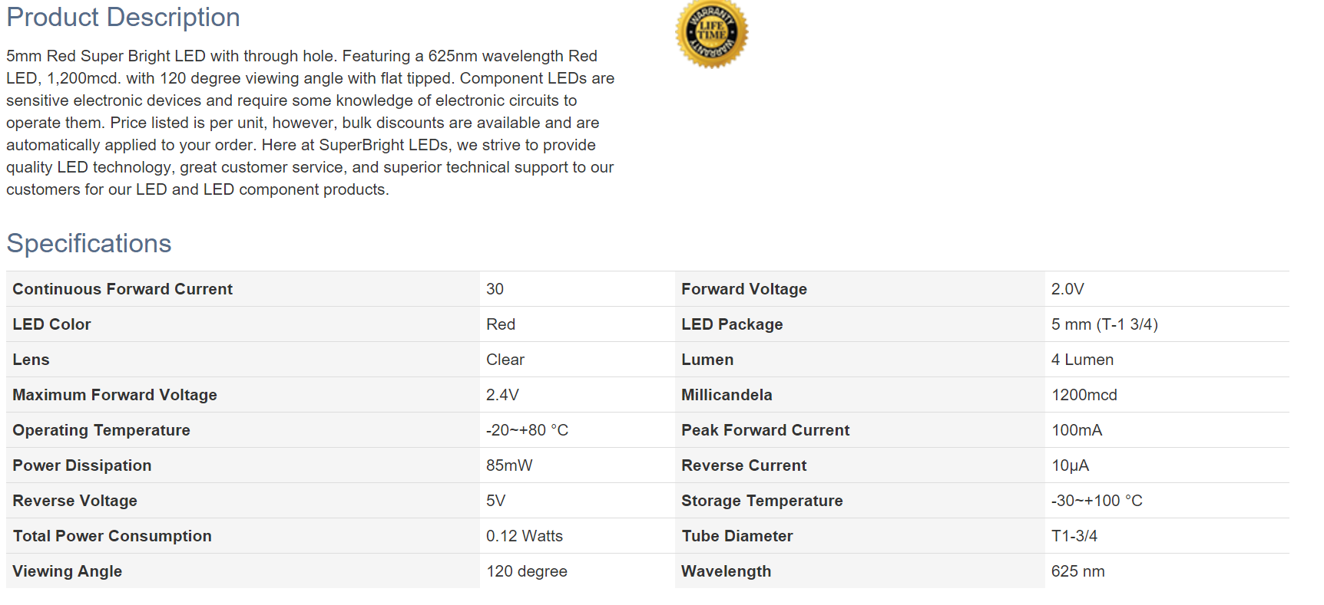

Full datasheet can be found [here](https://www.superbrightleds.com/moreinfo/through-hole/5mm-red-led-120-degree-viewing-angle-flat-tipped-1200-mcd/279/1206/)

### Tractive System Measurement Points

Referred to: 2.8

#### TSMP Box

Referred to 2.8

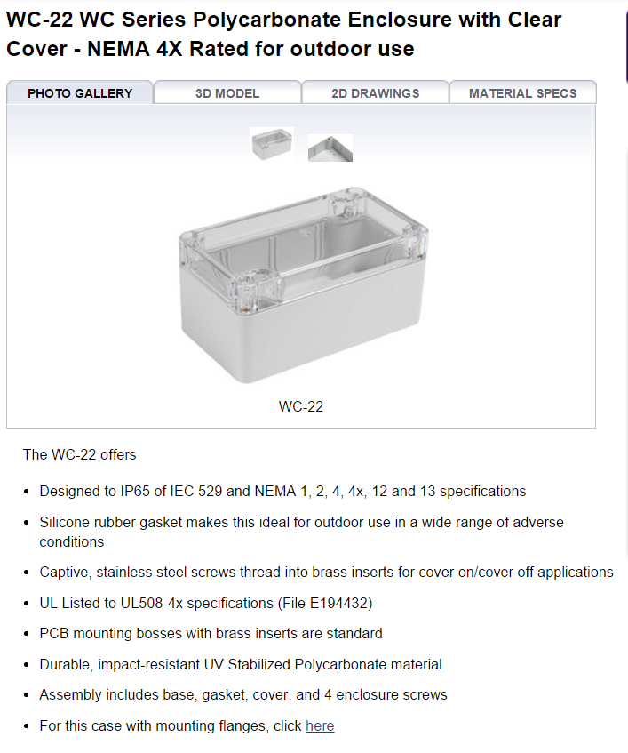

Full datasheet: [here](http://www.polycase.com/wc-22)

#### TSMP Jacks

Referred to 11.2.8

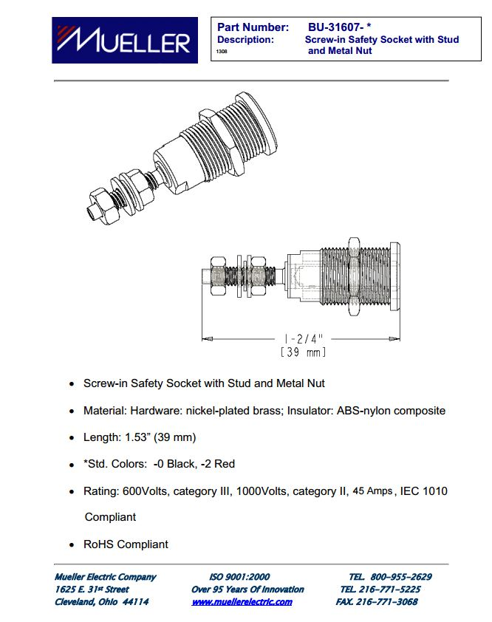

Full datasheet: [here](http://muellerelectric.com/wp-content/uploads/DS-BU-31607-0.pdf)

#### TSMP Resistors

Referred to 11.2.8

### Precharge Circuitry

#### 150 Ω Precharge Resistors

Referred to 2.9.1

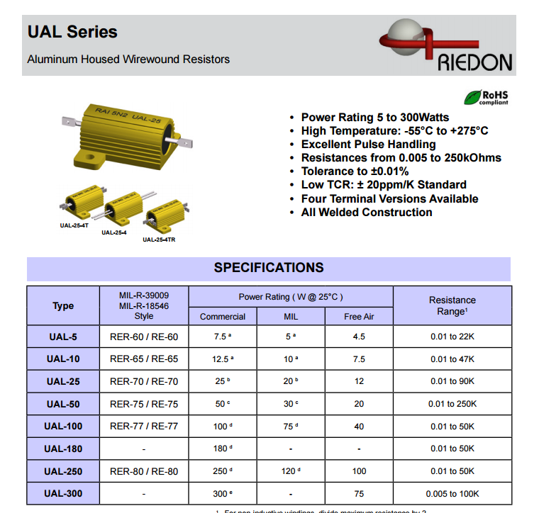

Full datasheet: [here](http://riedon.com/media/pdf/UAL.pdf)

#### Precharge High Voltage Relays

Referred to 2.9.1

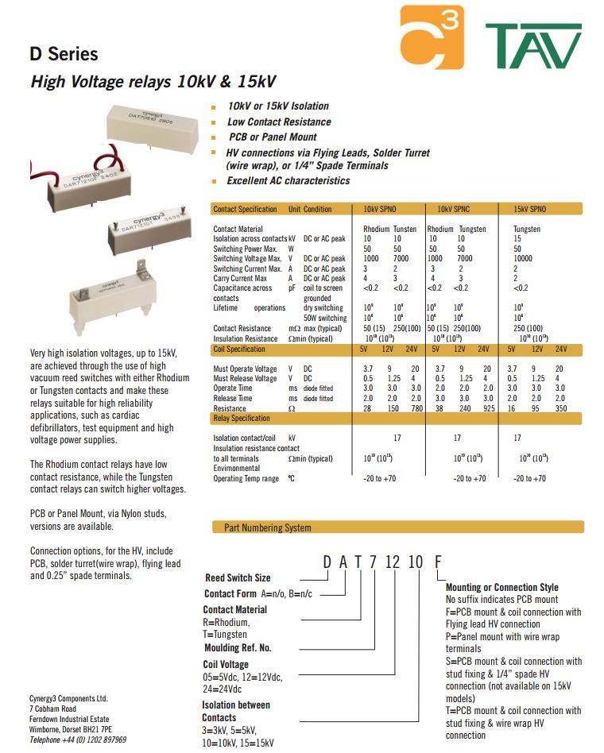

Full datasheet: [here](http://www.cynergy3.com/sites/default/files/product-data-sheets/D%20series%202013.pdf)

### Discharge Circuitry

#### Discharge Resistors

Referred to 2.10.1



Full datasheet: [here](http://riedon.com/media/pdf/UAL.pdf)

#### Discharge Relays

Referred to 2.10.1



Full datasheet: [here](http://www.cynergy3.com/sites/default/files/product-data-sheets/D%20series%202013.pdf)

### High Voltage Disconnect

Referred to 2.11

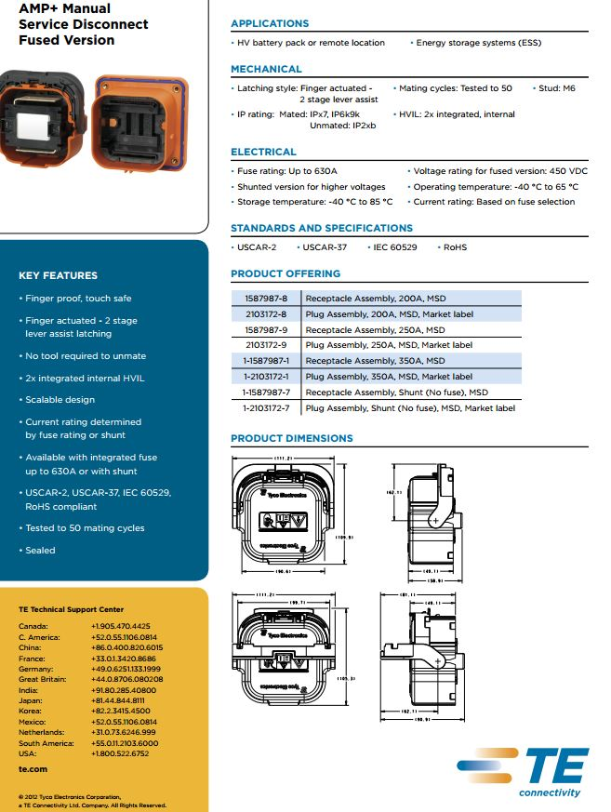

Full Datasheet: [here](http://www.te.com/content/dam/te/global/english/industries/hybrid-electric-mobility-solutions/amp-msd-tech-sheet.pdf)

### Ready To Drive Sound

#### Ready to Drive Horn

Referred to 2.12

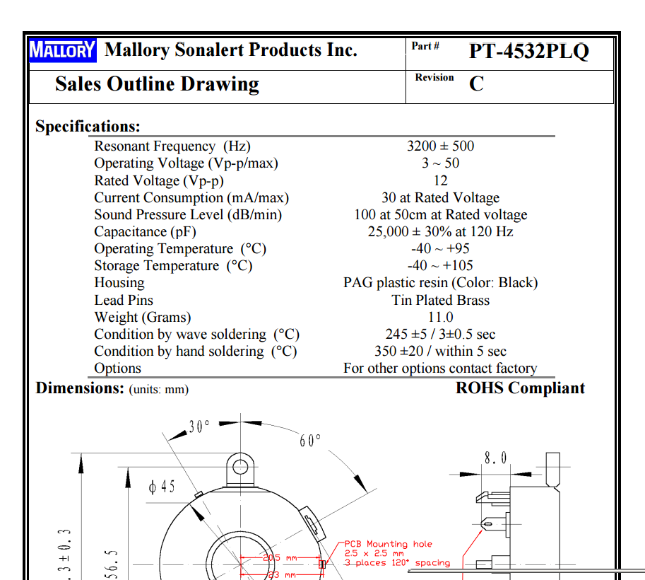

Full Datasheet [here](http://www.mouser.com/ds/2/252/PT-4532PLQ-18761.pdf)

## Accumulator

#### High Voltage Battery

Referred to 3.1.2

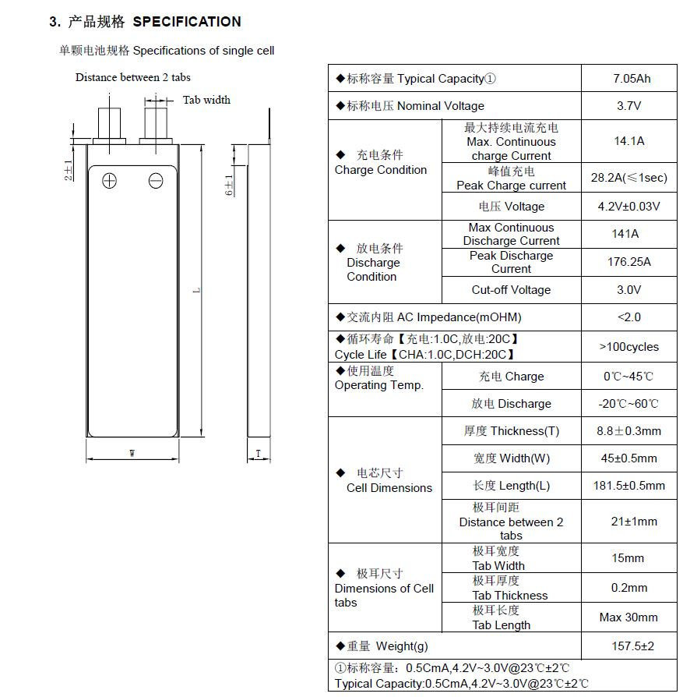

Full datasheet [here](http://www.melasta.com/product.asp?lie=Lithium%20polymer%20battery)

#### Maintenance Plugs

Referred to 3.1.11

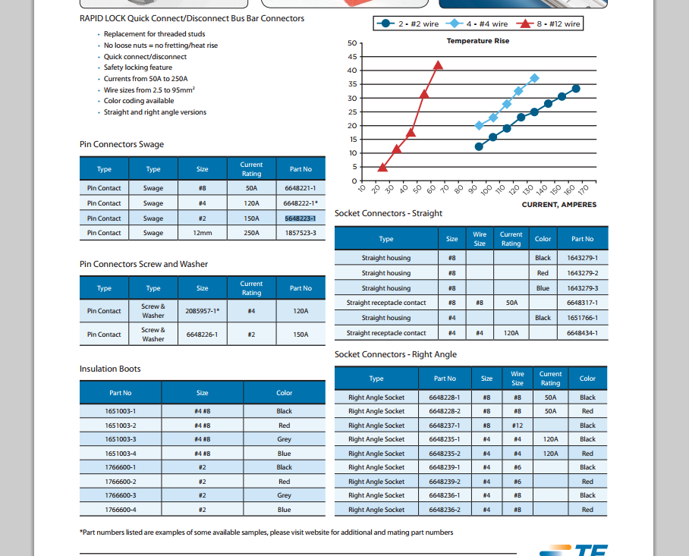

Full datasheet [here](http://www.te.com/usa-en/product-6648223-1.html#pdp-docs-features)

#### Accumulator Isolation Relay

Referred to 3.1.8

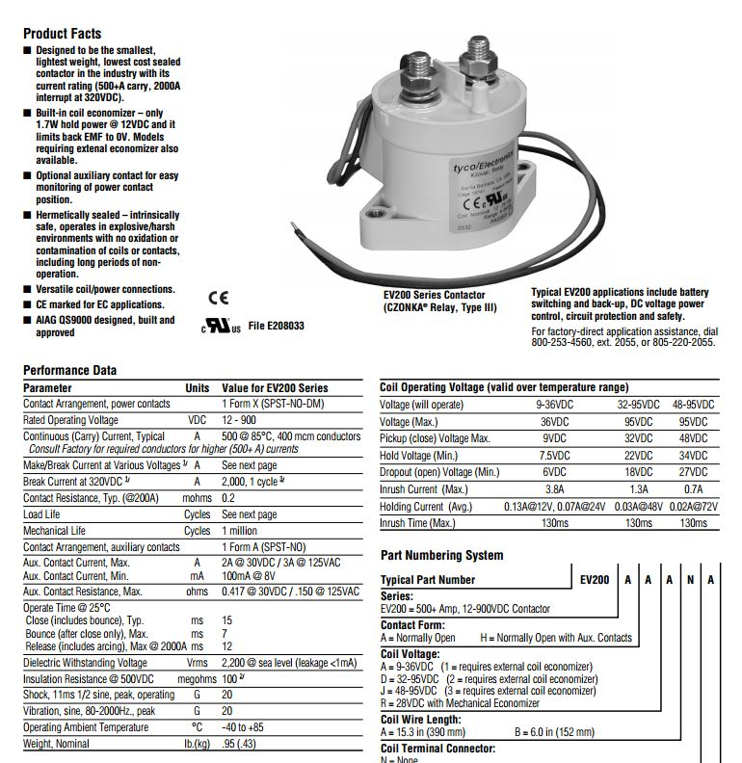

Full datasheet [here](http://www.te.com/catalog/pn/en/1618002-7)

#### High Voltage Fuse

Referred to 3.1.9

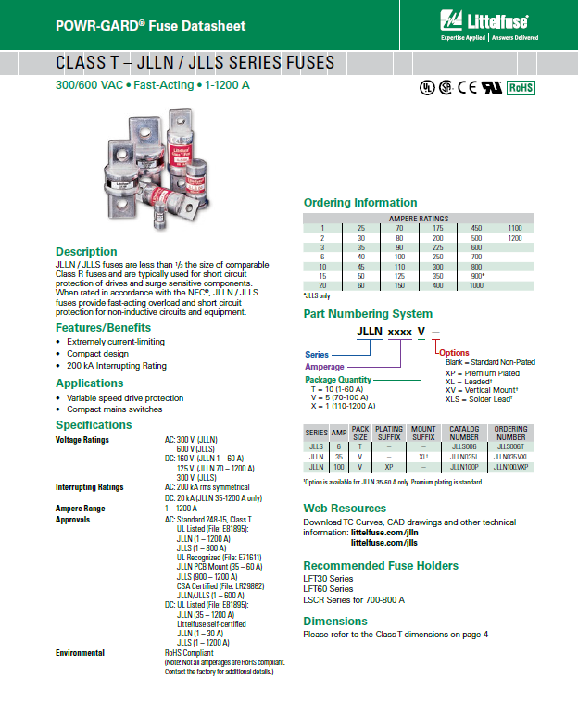

Full datasheet [here](http://www.littelfuse.com/~/media/electrical/datasheets/fuses/industrial-and-ul-fuses/littelfuse_fuse_jlln_jlls_datasheet.pdf)

#### HV Fuse Holder

Referred to 3.1.9

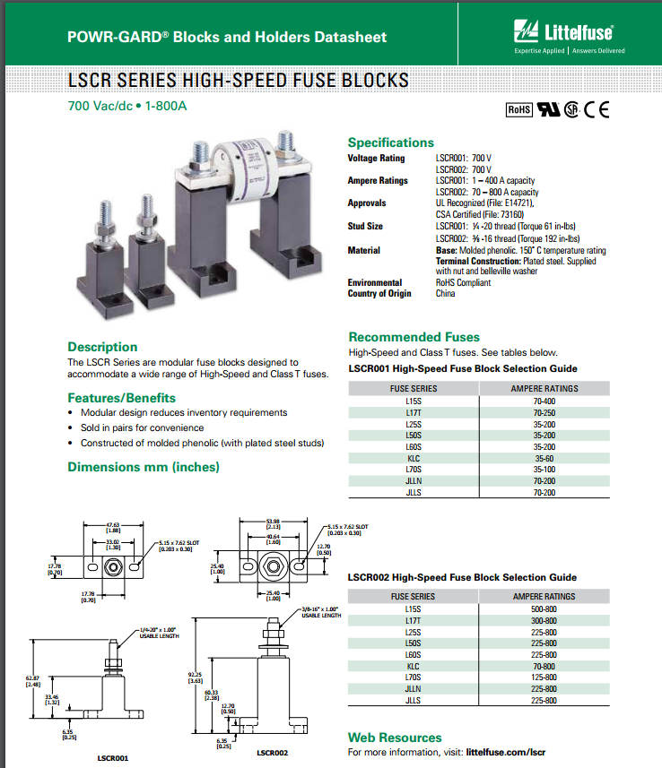

Full Sheet [Here](http://www.littelfuse.com/~/media/electrical/datasheets/fuse-blocks-and-holders/littelfuse_fuse_block_lscr_datasheet.pdf)

#### BMS Sense Fuse

Referred to 3.1.5



Full datasheet: [here](http://belfuse.com/pdfs/C1F.pdf)

#### Charger

Referred to 3.1.10

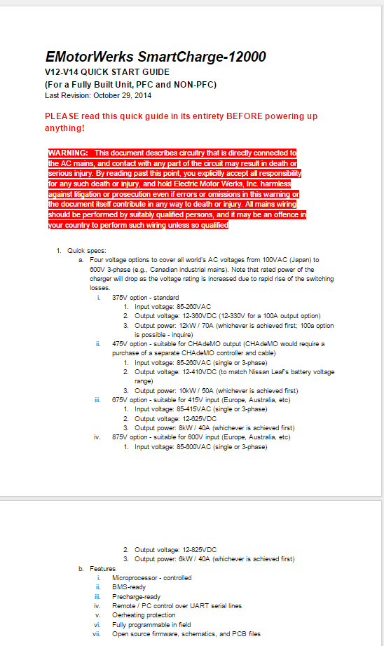

Full datasheet: [here](https://docs.google.com/document/d/14axudenSziPm8gjc8Sv2n5Np-XDPIssUk-YkXAVsxSw/edit)

## Energy Meter

Referred to 4.1

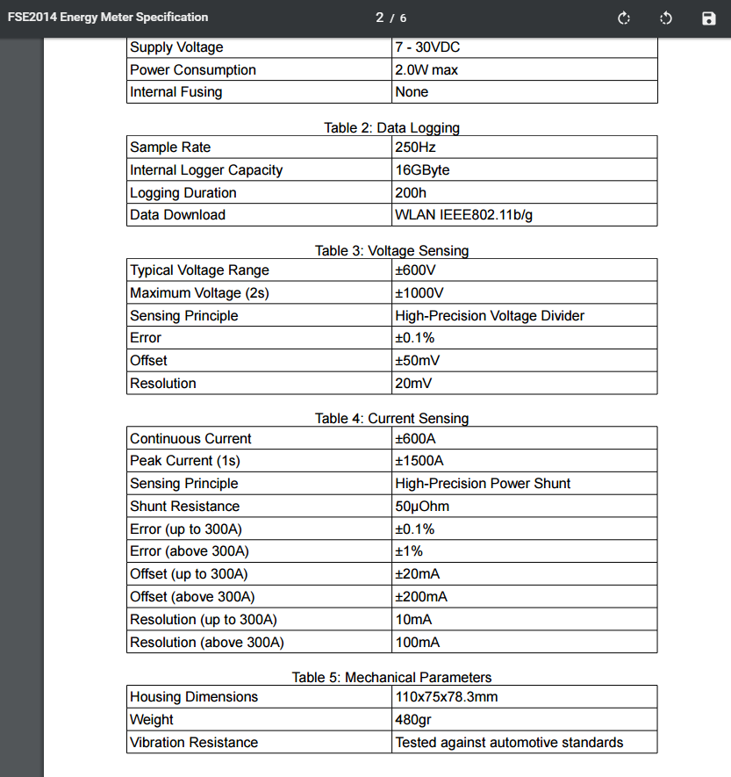

Full Specs [here](http://www.sae.org/images/cds/selfservice/396360463_FSE2014_Energy_Meter_Specification_v1.0.pdf)

## Motor Controller

### Rinehart Motion Systems PM100DX

Referred to: 5.1



Full datasheet can be found [here](http://www.rinehartmotion.com/files/Download/PM_Datasheet_01052012.pdf)

### EXRAD Shielded Cable

Referred to: 5.1.2



Full Datasheet can be found [here](http://www.champcable.com/product_pdfs/15_SAE_150_FX_Shielded_High_Voltage.pdf)

## Motor(s)

### EMRAX 228

Referred to 6.1.1

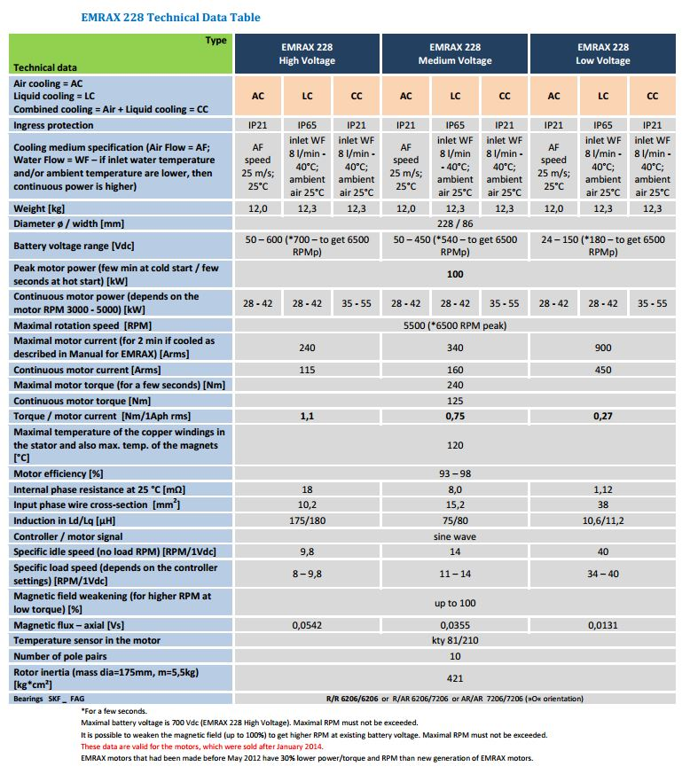

Full datasheet [here](http://www.enstroj.si/Electric-products/emrax-228-motorsgen.html)

## Torque Encoder

### Active Sensors Linear Potentiometer

Referred to 7.1

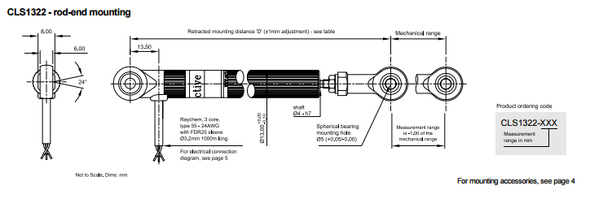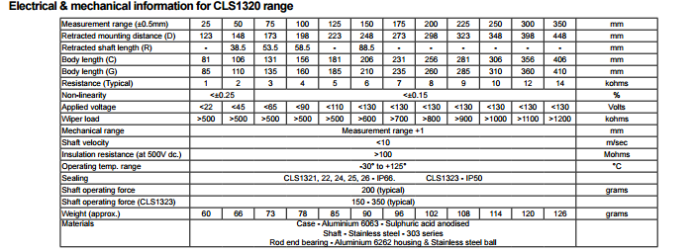

Full Datasheet can be found [here](http://www.activesensors.com/datasheet/linear-potentiometer/cls1300.pdf)

## LV Parts

### Low Voltage BMS

#### Low Voltage Battery

Referred to 8.1



Full Datasheet [here](http://www.batteryspace.com/prod-specs/3.7V10Ah.pdf)

## Grounding Concept

Referred to 9.1

## Firewall

Referred to 10.1